10.04

cat /proc/bus/input/devices

I: Bus=0017 Vendor=0001 Product=0001 Version=0100
N: Name="Macintosh mouse button emulation"
P: Phys=
S: Sysfs=/devices/virtual/input/input4
U: Uniq=
H: Handlers=mouse0 event4
B: EV=7
B: KEY=70000 0 0 0 0 0 0 0 0
B: REL=3

I: Bus=0003 Vendor=04b3 Product=310c Version=0111
N: Name="USB Optical Mouse"
P: Phys=usb-0000:00:1d.1-1/input0
S: Sysfs=/devices/pci0000:00/0000:00:1d.1/usb3/3-1/3-1:1.0/input/input7
U: Uniq=
H: Handlers=mouse1 event7
B: EV=17
B: KEY=70000 0 0 0 0 0 0 0 0
B: REL=103
B: MSC=10

I: Bus=0011 Vendor=0002 Product=0007 Version=01b1
N: Name="SynPS/2 Synaptics TouchPad"
P: Phys=isa0060/serio2/input0
S: Sysfs=/devices/platform/i8042/serio2/input/input9
U: Uniq=
H: Handlers=mouse2 event9
B: EV=b
B: KEY=420 0 70000 0 0 0 0 0 0 0 0
B: ABS=11000003

9.10

cat /proc/bus/input/devices

I: Bus=0017 Vendor=0001 Product=0001 Version=0100
N: Name="Macintosh mouse button emulation"
P: Phys=
S: Sysfs=/devices/virtual/input/input4
U: Uniq=
H: Handlers=mouse0 event4
B: EV=7
B: KEY=70000 0 0 0 0 0 0 0 0
B: REL=3

I: Bus=0003 Vendor=04b3 Product=310c Version=0111
N: Name="USB Optical Mouse"
P: Phys=usb-0000:00:1d.1-1/input0
S: Sysfs=/devices/pci0000:00/0000:00:1d.1/usb3/3-1/3-1:1.0/input/input7
U: Uniq=
H: Handlers=mouse1 event7
B: EV=17
B: KEY=70000 0 0 0 0 0 0 0 0
B: REL=103
B: MSC=10

I: Bus=0011 Vendor=0002 Product=0007 Version=01b1
N: Name="SynPS/2 Synaptics TouchPad"
P: Phys=isa0060/serio2/input0
S: Sysfs=/devices/platform/i8042/serio2/input/input9
U: Uniq=
H: Handlers=mouse2 event9
B: EV=b
B: KEY=420 0 70000 0 0 0 0 0 0 0 0
B: ABS=11000003

10.04

xinput list-props "SynPS/2 Synaptics TouchPad"
Device 'SynPS/2 Synaptics TouchPad':
Device Enabled (132): 1
Device Accel Profile (250): 0
Device Accel Constant Deceleration (251): 1.000000
Device Accel Adaptive Deceleration (253): 1.000000
Device Accel Velocity Scaling (254): 10.000000
Synaptics Edges (268): 1752, 5192, 1620, 4236
Synaptics Finger (269): 24, 29, 255
Synaptics Tap Time (270): 180
Synaptics Tap Move (271): 221
Synaptics Tap Durations (272): 180, 180, 100
Synaptics Tap FastTap (273): 0
Synaptics Middle Button Timeout (274): 75
Synaptics Two-Finger Pressure (275): 280
Synaptics Two-Finger Width (276): 7
Synaptics Scrolling Distance (277): 100, 100
Synaptics Edge Scrolling (278): 0, 0, 0
Synaptics Two-Finger Scrolling (279): 0, 0
Synaptics Move Speed (280): 0.400000, 0.700000, 0.009952, 40.000000
Synaptics Edge Motion Pressure (281): 29, 159
Synaptics Edge Motion Speed (282): 1, 401
Synaptics Edge Motion Always (283): 0
Synaptics Button Scrolling (284): 1, 1
Synaptics Button Scrolling Repeat (285): 1, 1
Synaptics Button Scrolling Time (286): 100
Synaptics Off (287): 0
Synaptics Guestmouse Off (288): 0
Synaptics Locked Drags (289): 0
Synaptics Locked Drags Timeout (290): 5000
Synaptics Tap Action (291): 2, 3, 0, 0, 1, 3, 2
Synaptics Click Action (292): 1, 1, 1
Synaptics Circular Scrolling (293): 0
Synaptics Circular Scrolling Distance (294): 0.100000
Synaptics Circular Scrolling Trigger (295): 0
Synaptics Circular Pad (296): 0
Synaptics Palm Detection (297): 0
Synaptics Palm Dimensions (298): 10, 199
Synaptics Coasting Speed (299): 0.000000
Synaptics Pressure Motion (300): 29, 159
Synaptics Pressure Motion Factor (301): 1.000000, 1.000000
Synaptics Grab Event Device (302): 1
Synaptics Gestures (303): 1
Synaptics Capabilities (304): 1, 1, 1, 0, 0
Synaptics Pad Resolution (305): 182, 121
Synaptics Area (306): 0, 0, 0, 0
Synaptics Jumpy Cursor Threshold (307): 0

9.10

xinput list-props "SynPS/2 Synaptics TouchPad"
Device 'SynPS/2 Synaptics TouchPad':
Device Enabled (95): 1
Synaptics Edges (240): 1752, 5192, 1620, 4236
Synaptics Finger (241): 24, 29, 255
Synaptics Tap Time (242): 180
Synaptics Tap Move (243): 221
Synaptics Tap Durations (244): 180, 180, 100
Synaptics Tap FastTap (245): 0
Synaptics Middle Button Timeout (246): 75
Synaptics Two-Finger Pressure (247): 280
Synaptics Two-Finger Width (248): 7
Synaptics Scrolling Distance (249): 100, 100
Synaptics Edge Scrolling (250): 1, 0, 0
Synaptics Two-Finger Scrolling (251): 0, 0
Synaptics Move Speed (252): 0.400000, 0.700000, 0.009952, 40.000000
Synaptics Edge Motion Pressure (253): 29, 159
Synaptics Edge Motion Speed (254): 1, 401
Synaptics Edge Motion Always (255): 0
Synaptics Button Scrolling (256): 1, 1
Synaptics Button Scrolling Repeat (257): 1, 1
Synaptics Button Scrolling Time (258): 100
Synaptics Off (259): 1
Synaptics Guestmouse Off (260): 0
Synaptics Locked Drags (261): 0
Synaptics Locked Drags Timeout (262): 5000
Synaptics Tap Action (263): 0, 3, 0, 0, 1, 3, 2
Synaptics Click Action (264): 1, 1, 1
Synaptics Circular Scrolling (265): 0
Synaptics Circular Scrolling Distance (266): 0.100000
Synaptics Circular Scrolling Trigger (267): 0
Synaptics Circular Pad (268): 0
Synaptics Palm Detection (269): 0
Synaptics Palm Dimensions (270): 10, 199
Synaptics Coasting Speed (271): 0.000000
Synaptics Pressure Motion (272): 29, 159
Synaptics Pressure Motion Factor (273): 1.000000, 1.000000
Synaptics Grab Event Device (274): 1
Synaptics Area (275): 0, 0, 0, 0
Synaptics Capabilities (276): 1, 1, 1, 0, 0
Synaptics Jumpy Cursor Threshold (277): 0

10.04

dmesg | grep Touch
[ 23.249272] Synaptics Touchpad, model: 1, fw: 7.2, id: 0x1c0b1, caps: 0xd04771/0xa40000
[ 23.304288] input: SynPS/2 Synaptics TouchPad as /devices/platform/i8042/serio2/input/input9

9.10

dmesg | grep Touch
[ 71.261391] Synaptics Touchpad, model: 1, fw: 7.2, id: 0x1c0b1, caps: 0xd04771/0xa40000
[ 71.320231] input: SynPS/2 Synaptics TouchPad as /devices/platform/i8042/serio2/input/input9

10.04
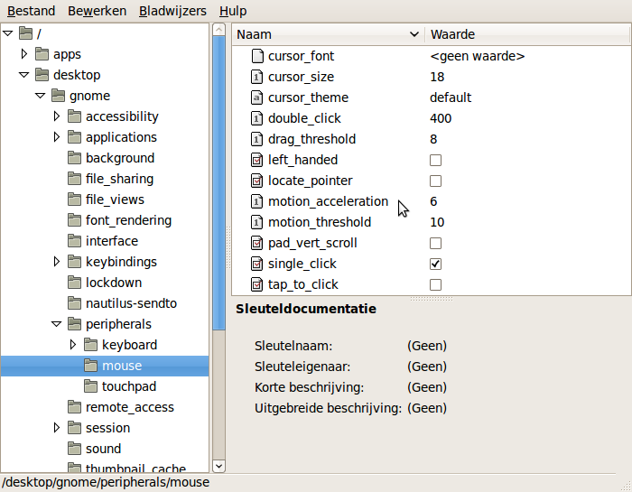

9.10
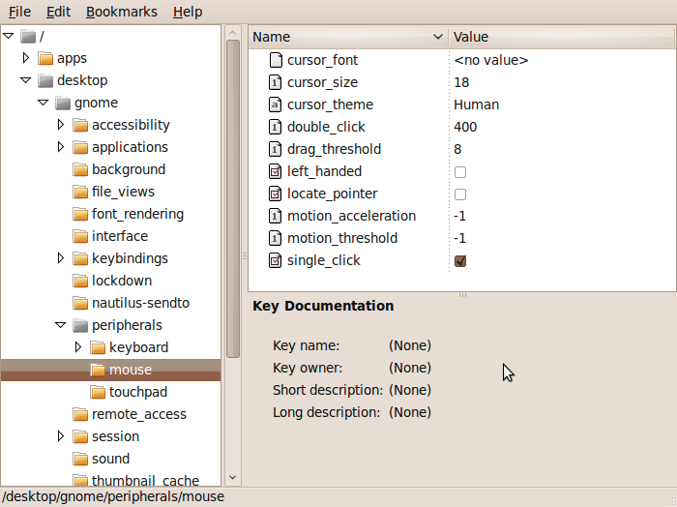
10.04
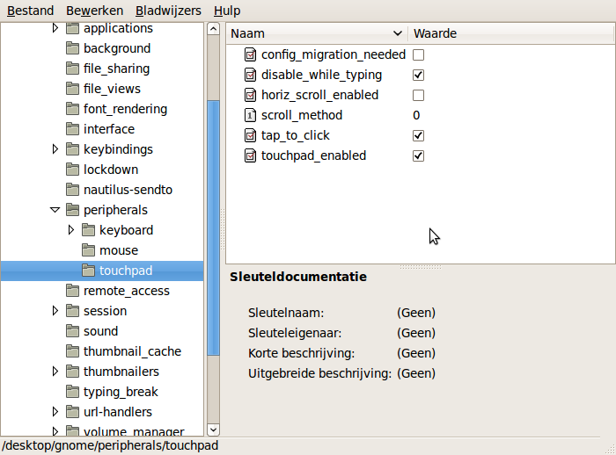

9.10
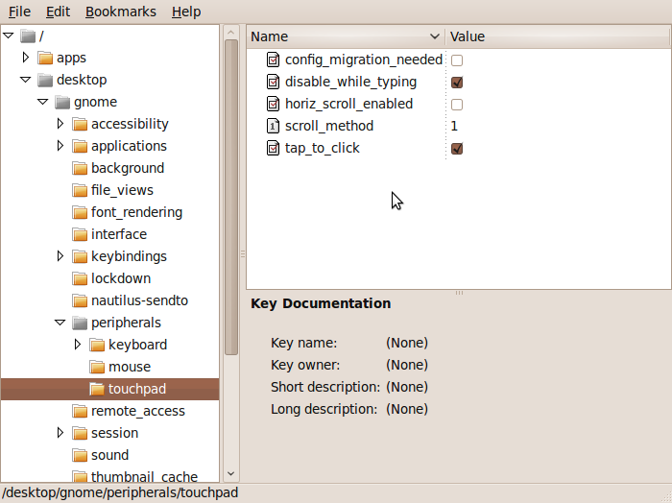

10.04
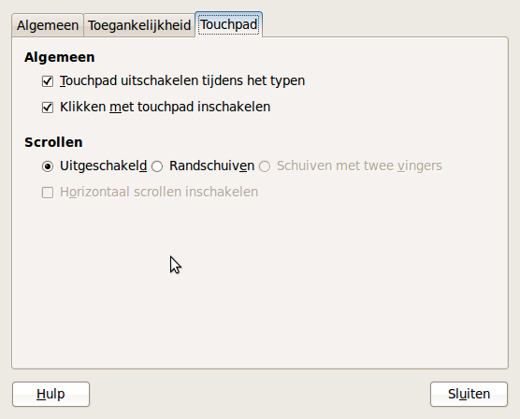

9.10


