Defining a 1TB storage
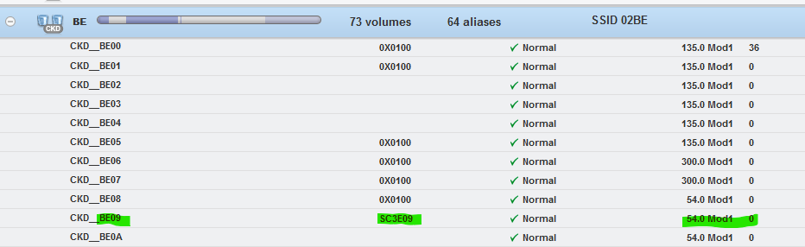
From the displayed, there are 135 Mod1, 300 Mod1, and MOD54 can be defined as 54 Mod1

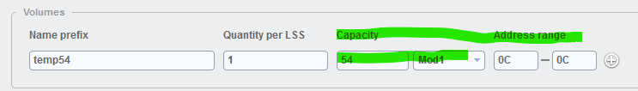
Defining a 54 Mod1 which is approximately a Mod54

Display of the 54 Mod1 that was defined previously

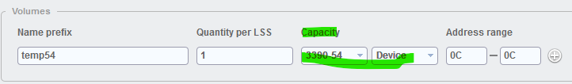
This is defining a traditional 3390 Mod54

