0) This is my newly installed Ubuntu 20.04 virtual machine via Parallels. I installed samba, and set to share ‘public’ folder by ‘local network share’ in Nautilus. Also I need to set a password for samba via smbpasswd. Of course I applied the updates by apt-get.
I opened three folders. (1) is my home folder, (2) is my public folder opened locally, and (3) is my public folder connected through samba (+ Other Locations > (Computer name) > public). In the home folder, there is a random ubuntu logo file I downloaded from the internet.
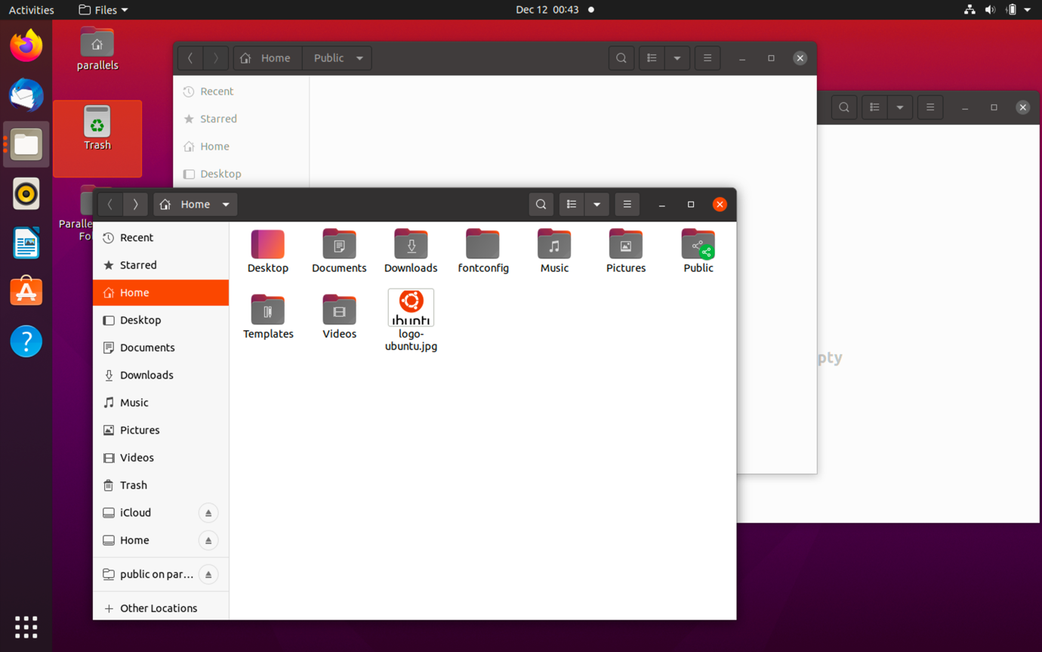
(1)
(2)
(3)

1) I copied the file to my public folder via samba. That means, folder (1) to (3). And then I deleted the original file in the home folder.
(It seems that the files written through the samba protocol were affected only, so by moving the file from folder (1) to (3), this file is now written through the samba.)
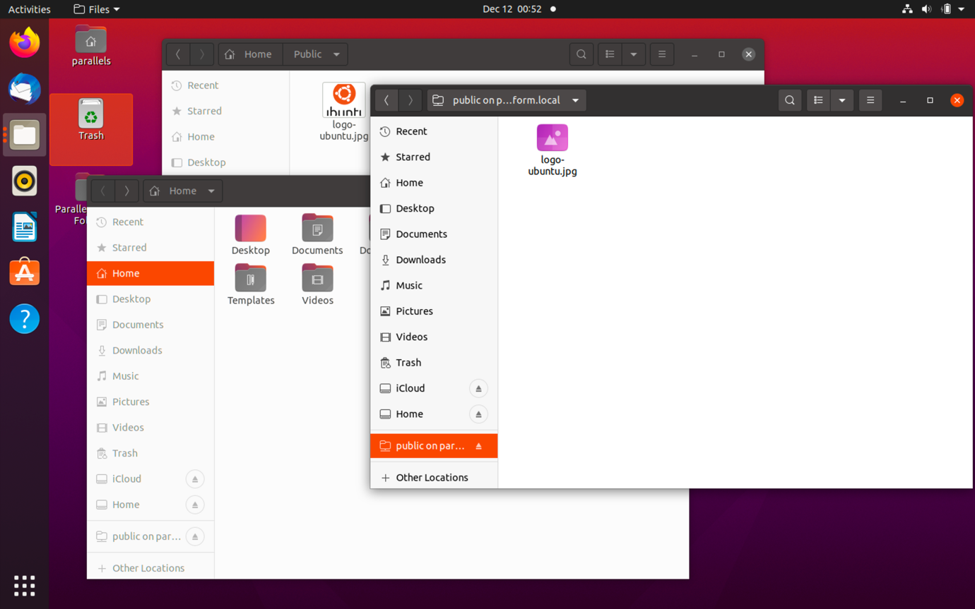

2) Now the file appears in folder (2) too. I moved this file to my home folder locally, means folder (2) to (1).
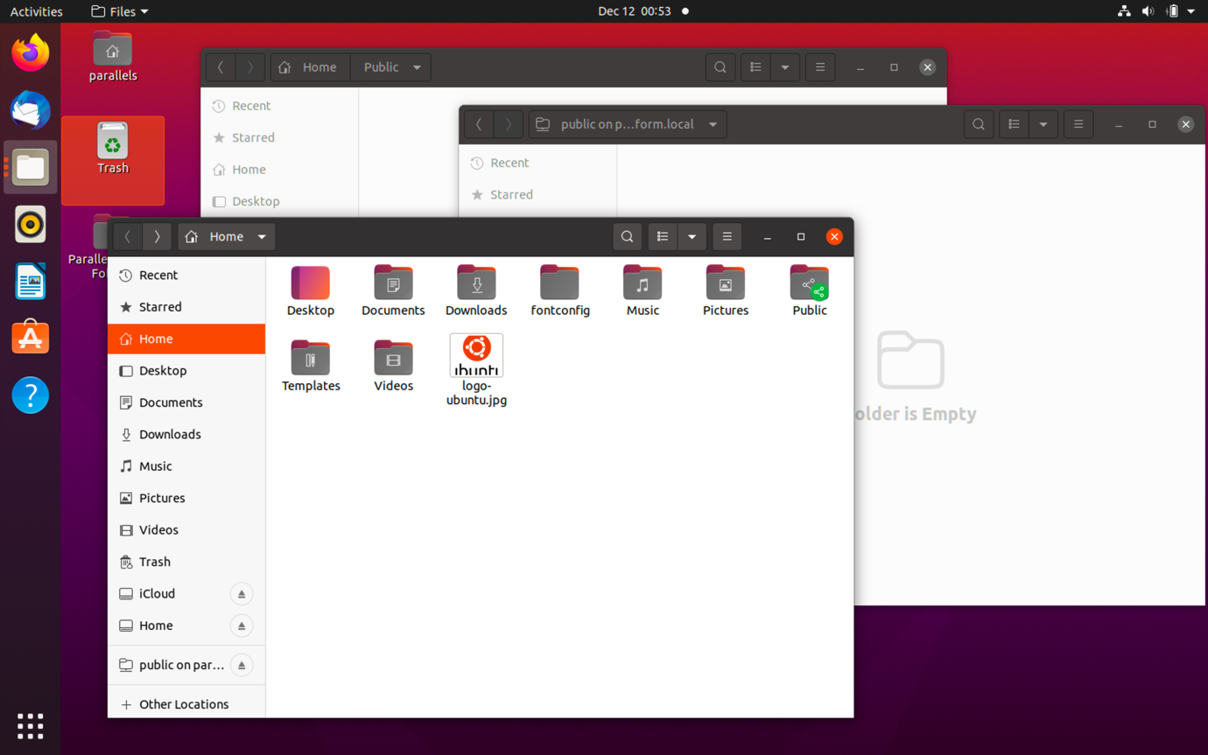
Move

3) And then I copied the file to the public folder, not using samba, means folder (1) to (2), not (3). (Strangely, moving the file did not make the problem.)

4) Refresh the folder (3). Now the file is shown as a folder.
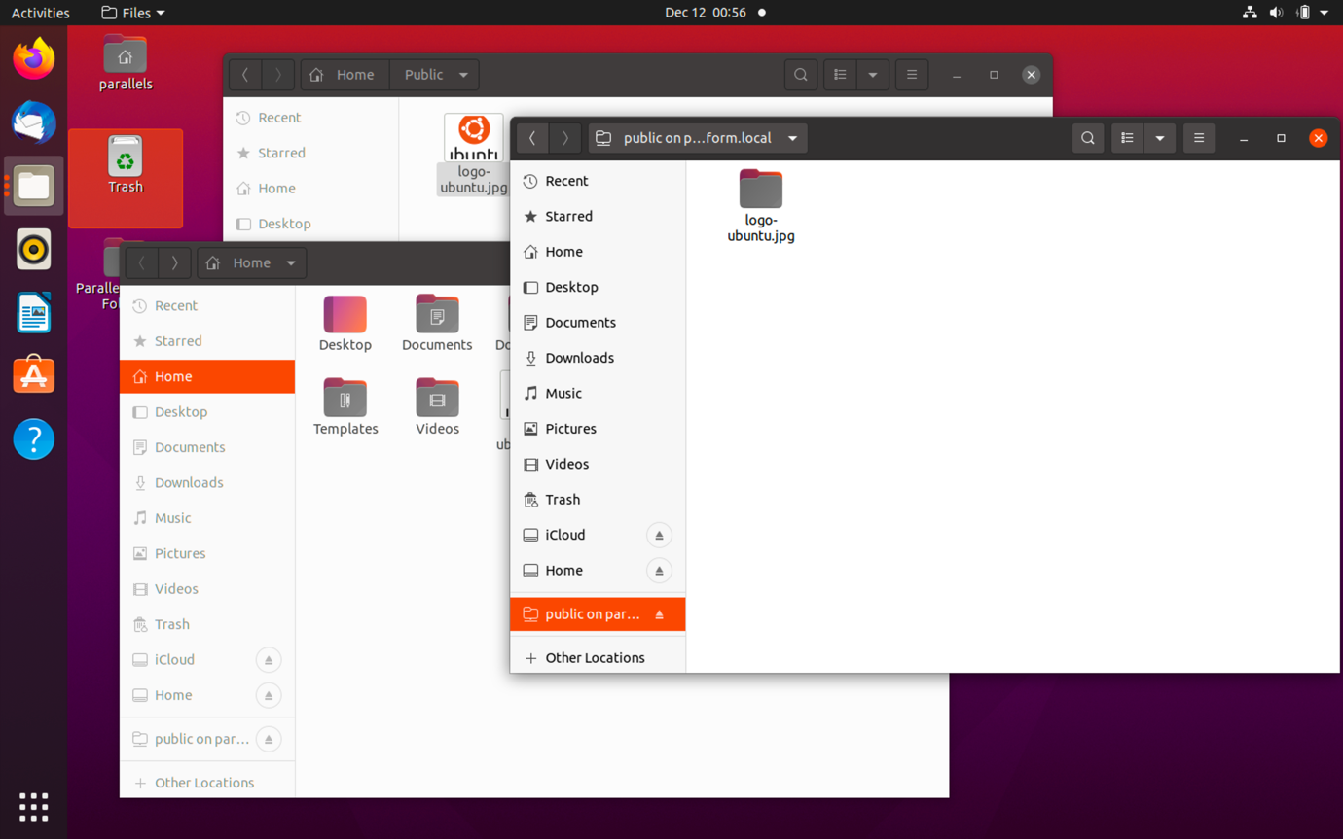
Copy

