Method to Observe Frequency of Oscillating LED
Leif Andersen

Abstract

IV. Introduction
Light Emitting Diodes (LED), can be used to determine the period of an osculating wave. This lab deals with a circuit, based around an opp-amp, capacitors, resistors and potentiometers, to make the circuit osculate. A diode and capacitor is added into the circuit to cause the LED to fade in and out, rather than simply turning on and off.
The first part of the lab is to design the astable multivibrator, then it is tested, then, the visual fusion rate is found, and then the LED portion of the circuit must be built and tested. Finally, a test is done to test the participial vision of a person. (Snubbed).

2. Design of the Astable Multivibrator
A. Selection of R1 and R2
The following is the type of circuit needed to build an astable multivibrator:
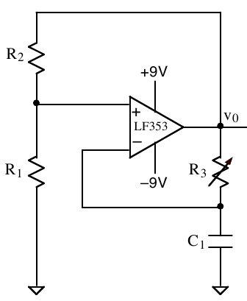Figure 1: Astable Multivibrator
Where each of the components are adjusted to the maximum voltage across the capacitor, before the total outputted voltage V_{o} is flipped. Furthermore, the general equation for finding a voltage on a capacitor in an RC circuit can be used:

(1)

Thus, the capacitor will charge at an exponential rate, until some voltage V_{trip} is reached, at which point, the capacitor will flip, and start charging in the other direction. Furthermore, the circuit consumes 10 mA, and the LED will consume 7 mA, thus:

(2)
The following can be said about V_{trip}:

(3)
Or:

(4)
Which simplifies down to:

(5)
We can also write the equation

(6)
Combining Equation 5 and 6:

(7)
Taking V_{O} = 9

(8)
Combining equations 8, 2 and 5:

(9)

(10)
Equation 5 must still be met.
B. Selection of R3 and C1
Keeping in mind that the needed period T is:

(11)
And remembering that T is directly proportional to R_{thev}C, the following values are good to take:

(12)
Plugging this into equation 1, and solving for R₃ gives:

(13)

3. Construction and Testing of Astable Multivibrator
A. Measured Component Values
The following are the found value of the various components, R₃ is set to obtain the minimal period.
Table I: Found Values for components:
Component | Theoretical Value | Found Value
R₁ | 80 kΩ | 81.615 kΩ
R₂ | 4.3 kΩ | 4.343 kΩ
R₃ | 1.6 kΩ | 1.265 kΩ
C₁ | 0.1 µF | 0.105 µF
B. Square Wave Frequency
Building Figure 1 makes a good astable multivibrator circuit. Alternatively, the following circuit would work:
However, for the proceeding test, the circuit in Figure 1 was built. Plugging in the values in Table 1, should result in the lower half of the scale in Equation 11. The time taken for one osculation can be evaluated as such:
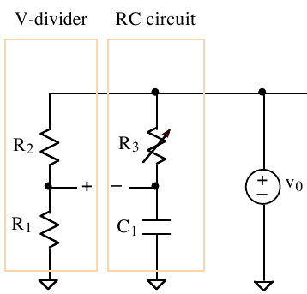Figure 2: Alternative Circuit

(14)

C. Predicted and Measured C1 and vo Waveforms
Do to a typo in this lab, C₁ was replace with C₂ for this test. C₂ = 1 µF ~ 995 nF. The circuit was plugged into the oscilloscope, and the values for V_{O} and the voltage across the capacitor is superemposed onto the predicted values for the graph, based on the actual values for the resistors.
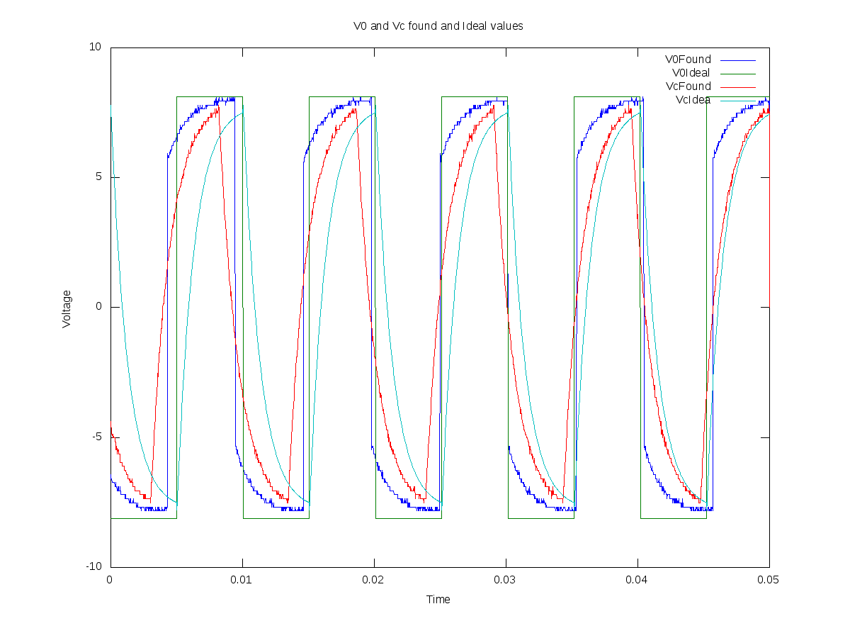Graph 1

D. Measured Value of R4
The following is the second half of the circuit, the part that contains the LED, and a capacitor to cause it to fade in and out.
As prescribed by Figure 3, the following value can be gained for R₄:
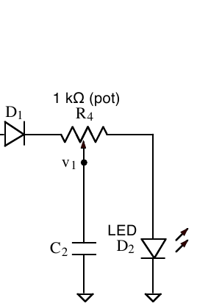Figure 3: LED Circuit
Table 2: Actual and Found Values for R₄
Component | Theoretical Value | Found Value
R₄ | 1 kΩ | 938 Ω

E. Flashing LED Rate
Adjusting R₃ to a rate such that the LED appears to be a constant stream, rather than a flashing light, leads to the following rate, just under the fusion rate.

(15)
Or:

(16)

4. Measurement of Visual Fusion Rate
A. Critical Fusion Frequency
The continuous fusion rate is is the frequency just above the one listed in equation 16.

B. LED Voltage
By connecting a probe across the LED, we are able calculate the voltage drop due to the LED:

(17)

C. LED Current
It is possible to calculate the maximum possible current across the LED, by calculating the current across R₄. Taking:

(18)
Plugging into Ohms law, the current is:

(19)
This is well bellow the 20 mA limit of the LED.

5. Design and Construction of LED Circuit
A. Equation for v1 Before and After LED Turns On
Due to D₁, the LED portion of the circuit can be modeled as two circuits, one while C₂ is charging, and one where it is discharging.
There are two main states that this circuit will oscillate through, where the capacitor is completely charged, and discharged. These states are:
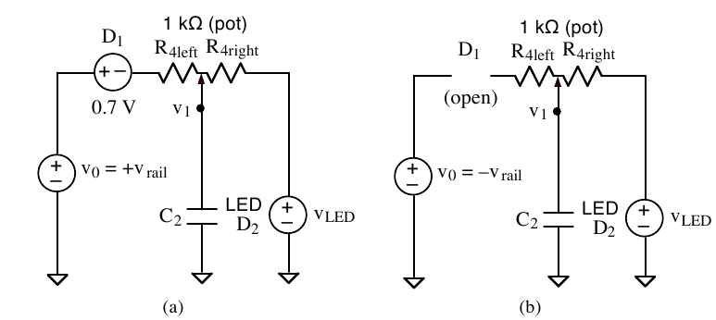Figure 4: Open and closed Diode Circuit

(20)
And:

(21)
Furthermore, the period being RC, gives the following equation:

(22)

Plugging these equations into equation 1, the following equation is created for V(t):

(23)
And:

(24)
Where V_{LED} is the maximum voltage of the LED, as the voltage when the LED is turned off is zero, it has been removed from the equation.

B. Sketch of v1 vs Time
Because the voltage is generated by the general equations, it should look like an oscillating series of exponential waves. The minimum amount should be V_{LED+}, and the maximum, should be V₀ - D₁ = 7.85 V.

C. Sketch of iLED vs Time
Because they are in series, the current across the LED, and the current across the right portion of R₄ should be the same. Thus, this equation:

(25)
Because equation 25 is linearly correlated to equation 24, the shape is the same. Therefore, the shape is the same, except it is scaled down, so that the minimum current is 0 A, and the maximum current is 31.935 mA.

D. Calculation of Potentiometer Setting
The following equation is

ombined with equation 22 to provide one of two equations:

(26)
The second one is:

(27)
With two equations, and two unknowns, we can get the equations:

(28)`

E. Plot of v1 vs Time
Hooking an oscilloscope to the capacitor, and measuring it's voltage, returns a plot like this:
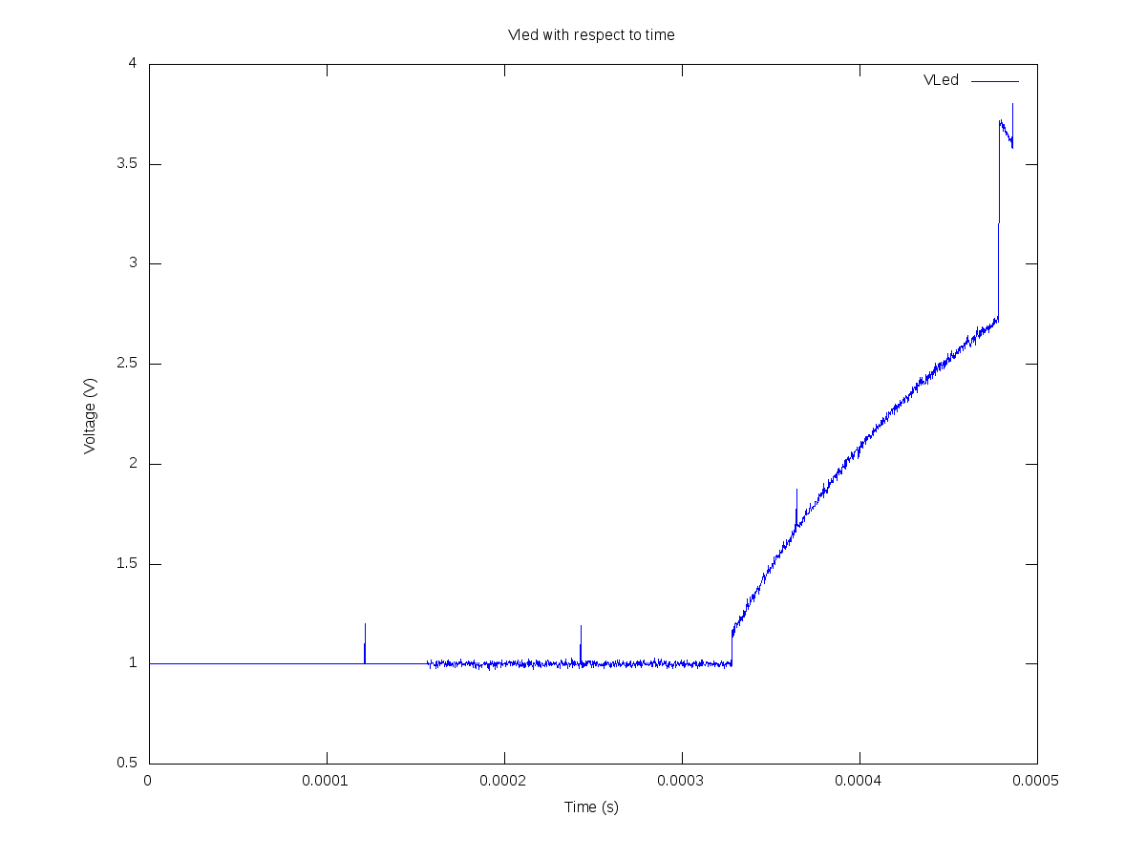Graph 2
F. Plot of iLED vs Time
Plugging these results into the equation found in D, gives the following plot:
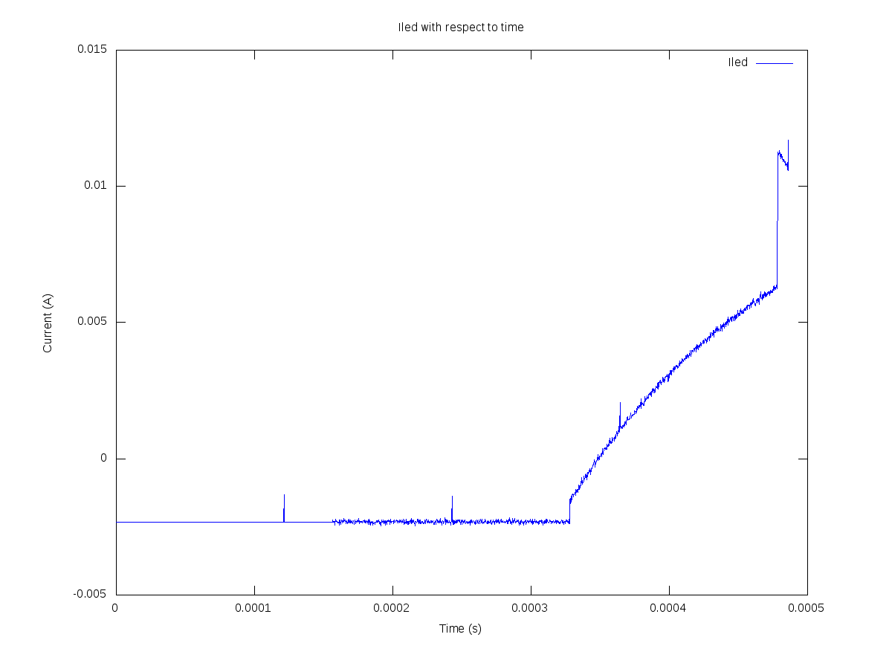Graph 3

6. Measurement and Analysis of Peripheral Visual Perception
A. Perceived LED Flash Rate for Central Field of View
Snuffed.

B. Perceived LED Flash Rate for Peripheral Vision
Snuffed.

C. Sketch of Peripheral Vision Response Waveform
Sunffed.

6. Conclusion
Based on these results, we can conclude that an opp-amp, connected to capacitors, resisters, and an LED, produces an oscillating wave. Furthermore, and additional capacitor can be used to cause the LED to fade, rather than simply flashing. It can also be determined that the fusion rate for and LED, is about 33.333 Hz. Nothing was learned about the difference in the center and peripheral vision of humans, as that portion was snubbed.

Appendix A
The following is the matlab code used for this lab:
%Code to observe the square wave
R1 = 81.615e3; %82e3
R2 = 4.373e3; %4.3e3
C1 = 995e-9; %1e-6
R3 = 1.265e3; %1.6e3
T = R3 * C1;
V0Found = dlmread('BoxPlot.txt');
VcFound = dlmread('Capacitor.txt');
V0Ideal = []; %-9V
Vtrip = max(VcFound);
VcIdeal = [];
t = linspace(0,0.05, length(V0Found));
flip = 1;
t1 = 1;
for t0 = 1:length(t)
VcIdeal(t0) = Vtrip*-flip+(2*Vtrip*flip)*e^(-t(t1)/T);
V0Ideal(t0) = max(V0Found)*-flip;
if (t1 > 200)
flip = flip * -1;
t1 = 1;
else
t1 = t1 + 1;
end
end

plot(t, V0Found, t, V0Ideal, t, VcFound, t, VcIdeal);
legend('V0Found', 'V0Ideal', 'VcFound', 'VcIdea');
title('V0 and Vc found and Ideal values');
xlabel('Time');
ylabel('Voltage');
print png 'VFound.png'

%Code for calculating iLED from VLED
Vt = dlmread('Vled.txt');
resolution = length(Vt);
Vled = 1.463; %0 at the other end
C2 = 995e-9; %1e-6
Vr4 = 2.6;
R4 = 938; %1e3
Ir4 = Vr4/R4;
D1 = .7;
Vrail = 8.55;
V0 = Vrail;
R4right = 200;
R4left = 800;
t = linspace(0,486e-6,resolution);
T = R4right*R4left/(R4right+R4left)*C2;
Vmax = ((V0 - D1 - Vled)*R4right/R4);
It = [];
for t0 = 1:resolution
It(t0) = (Vt(t0)-Vled)/R4right;
end

plot(t,Vt);
title('Vled with respect to time');
xlabel('Time (s)');
ylabel('Voltage (V)');
legend('VLed');
print png 'Vled.png';

plot(t,It);
title('Iled with respect to time');
xlabel('Time (s)');
ylabel('Current (A)');
legend('Iled');
print png 'Iled.png';

