Calorimetry
Andrew Farris
MEEN
Experiments 8 & 9
Friday, December 4, 2009

Abstract
Calorimetry is the study of the energy properties of materials, conducted typically by incinerating a small material sample and measuring the thermal energy outputs of the material, relative to the burned mass. In this set of experiments, we measured the caloric energy of a combusted peanut using latent heat calorimetry, constructed a calorimeter and used the it to determine the identity of an unknown alcohol by means of sensible heat calorimetry, and finally we measured the specific heat of a platinum wire using AC calorimetry and the omega technique. Through these techniques we were successfully able to measure the caloric energy of a peanut to approximately 1.8 kcal/g, determine the identity of the unknown alcohol to be isopropyl alcohol, and determine the specific heat of the platinum wire to be 42.73 kJ/kg-K, an extraordinarily wrong number.

Introduction
Calorimetry is the measurement of the quantities of energy stored within objects. The energy properties of these objects, i.e. internal energy, are difficult to quantify in their natural form, therefore in order to determine the magnitude of these quantities, we must utilize clever methods to measure them via routes we have easy access to.
Thanks to the first law of thermodynamics, and using methods of calorimetry called sensible heat calorimetry and latent heat calorimetry, we can deduce the caloric content of numerous substances by either adding energy to the system and observing the change in the thermodynamic state, or by combusting the substance and examining the energy output from that process. All these methods make easier the task of calculating important engineering and thermodynamic properties of materials, such as their specific heat.
In addition, there is also a special calorimetry technique, called the the omega technique, which can be used to measure the specific heat of a conductive material by applying a current to the material, and examining the change in the phase angle as the substance heats up.
In the lab exercises covered here, all three of these calorimetry techniques were utilized in the taking of measurements of several different substances, namely a food-grade peanut, a volume of unknown alcohol, and a platinum wire.
Background and Theory
According to the First Law of thermodynamics, the energy of any system can easily, and cleanly be defined with one simple equation:

where ΔE is the energy change of a system, δQ is the heat crossing a system boundary, and δW is the work crossing a system boundary. This rule of nature allows for easy interrogation of any one of the properties of a system, in our case ΔE.
For sensible heat calorimetry, the system is a fluid sealed in a well-insulated container, and by adding energy to this system, the internal energy of the system is increased. This increase in internal energy manifests itself as a temperature rise. Representing this process with the First Law yields the following equation:

where m is the fluid mass, c_{p} is the fluid specific heat, and ΔT is the resulting temperature change. In this way, it is possible to very easily determine the specific heat of the fluid, simply by measuring it's mass. The change in temperature, and the amount of energy added to the system.
For latent heat calorimetry, the system is a pure substance, either solid of fluid, on the threshold of a phase change. Adding energy to this system causes some of the pure substance to change phase, yielding important thermodynamic data from the process. Representing this process with the First Law yields the equation

where m is the mass of the substance that changed phase and ΔH is the latent heat of phase change for that substance. This is yet another example of how important thermodynamic data can be extracted from a system, simply by measuring a few important parameters.
The next form is calorimetry explored in this lab is a form of AC calorimetry called the “omega technique.” This technique uses an AC current source to measure the 'phase lag' of the current as the substance changes thermodynamic states (see Illustration 1 below).
Phase Lag
Illustration 1: A demonstration of phase lag
Because of the fact that resistance is a linear function of temperature, the resistance of the micro-wire can be easily determined at any given temperature from the equation

where T₀ is a reference temperature, and R₀ is the resistance at that temperature. By applying a sinusoidal AC current to a micro-wire sample, its temperature fluctuates at twice the input frequency. Therefore, from the above relation, R is also fluctuating at . Finally, the product of this calculated resistance and the input current yields a voltage, which is a multiple of a certain fundamental frequency, i.e. the term. The d harmonic component, called the “omega voltage” can be obtained by solving the transient dimensional heat conduction equation for a micro-wire.

where h is the convective heat transfer coefficient, ρ is the density, c_{p} is the specific heat, D is the diameter of the wire, and is the time constant, represented by

where L is the length of the wire sample, and α is the thermal diffusivity. In this formula, the only dependent variable is the phase lag, , due to the thermal response time of the wire. This allows for easy extraction of the specific heat property of the micro-wire.

Experiment and Procedure
For the first part of the experiment, we had to select a calorimeter, and quantify the energy infusion capabilities of the device, both by thermal infusion, and mechanical infusion. The calorimeter we selected was a student-made device, created by another class. Unfortunately, the calorimeter that was presented initially to us was in poor condition, and was unable to safely and accurately give us the data we required. As a result, we were forced to modify an additional calorimeter by adding measurement ports, and a method of work infusion, in order to obtain our results. The modified calorimeter is pictured Illustration 2 below. As an additional note, due to the clear superiority of our calorimeter over the original, the remaining groups that came after us to do the experiment favored the use of our calorimeter over the one we were initially presented with.
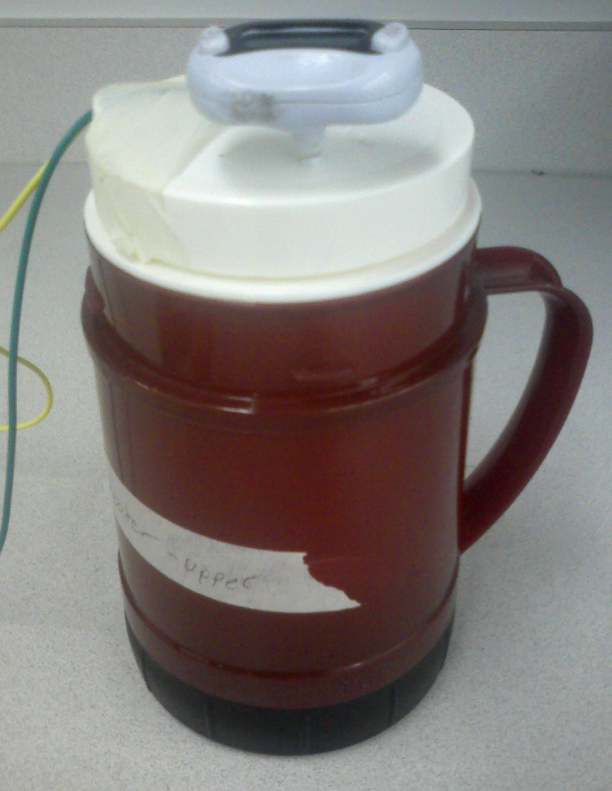Illustration 2: The coffee-cup calorimeter used in this experiment
Following instructions found in the laboratory manual, we filled the calorimeter with water, then determined the mass of water in the calorimeter and its initial temperature. Using this information, and the first law of thermodynamics, we then calculated what quantity of energy would be required to raise the temperature of water in the calorimeter by 1°C. Following this, we used the heat infusion capability of the calorimeter to apply the exact amount of energy calculated by way of joule heating with a resister submerged in the water. The power input was determined by the power input into the resister, assuming the resister dissipated 100% of the energy applied.
After testing the heat infusion capabilities of the calorimeter, the mass of water from the first test was flushed, and replaced with a fresh water sample. Following the same general procedure as with the heating mechanism, but using the work infusion capability of the device, we applied the exact amount of energy calculated earlier to the new mass of water, using the first law of thermodynamics. The amount of work input into the system was estimated with the electrical input to the motor, and the efficiency of the motor, as represented on the motor manufacturer's website.
For the next portion of the experiment, the caloric content of a food-grade peanut was measured using latent heat calorimetry. The calorimeter used for the latent heat measurements was not the same as the one from the first portion of the experiment. The calorimeter from this part of the experiment consisted of a tin can, which was filled with a known mass of water ice. The peanut was carefully selected for ideal size, and special care was taken to ensure that Brain Kaylor did not eat the peanut. The experiment itself was conducted by placing the peanut on a wire stand beneath the latent heat calorimeter, and then lighting it on fire with a chemical fire-starter. Using a beaker to catch the volume of ice that melted, the amount of energy produced by the burning peanut could be estimated, taking into account the mass of the peanut that burned. The magnitude of the caloric heat output of the peanut was then compared with the caloric values on the FDA food label, to verify continuity of the data.
The next part of the experiment consisted of identifying an unknown pure alcohol by sensible heat calorimetry. Using the calorimeter from the first part of the experiment, and adding heat with the devices' heat input method, the specific heat of the unknown alcohol was determined using the same methods as in the first part of the experiment. This determined specific heat value was then used to determine the identity of the unknown liquid.
The final part of the experiment consisted of using the 3-omega method described in the Background and Theory section to determine the specific heat of the platinum wire using the provided phase angle measurement device, pictured Illustration 3 below. By comparing the measured value to the calculated value, we were able to verify the continuity of the measurement data.
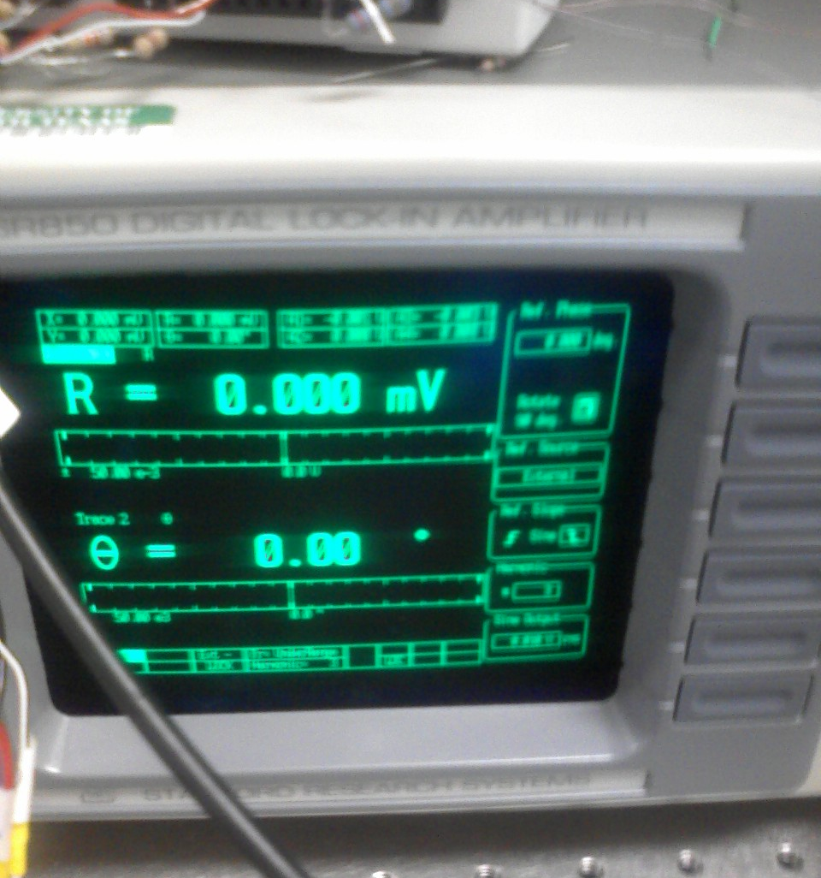Illustration 3: Phase angle measurement device output display

Results and discussion
For the first portion of the laboratory exercise comparing the chosen calorimeter's heat and work input methods, the data that was gathered is displayed in Table 1 on page 6. The actual energy required to change the temperature of the water by 1°C was calculated using the first law of thermodynamics, and taking the specific heat c_{p} of water to be 4.179 kJ/kg-K:

With uncertainties:

After calculating this, the times required to run each input method, we estimated the time that would be required to output this amount of energy via each method with the following:

The efficiency for the mechanical work input method was estimated using the efficiency for the motor of the work input mechanism, as defined by the manufacturer specs.
Next, the experiment was run with each infusion method, until a temperature change of 1°C was observed. The final results are shown below in Table 1.
Table 1: Data from the first part of experiment 1
In this table, the mass represents the mass of the water in the calorimeter, the temperature was the starting temperature of the water, time is the time it took to input the energy into the system, and Energy Input is the actual amount of energy that was put into the system. In addition, the uncertainties were calculated, which included factors of the uncertainty of the time measurements, as well as the recorded temperature of the water, however for space considerations the calculations themselves have been omitted.
From these data points it is clear that the mechanical energy input method was much closer to the anticipated energy/time values, being only 13.97% and 10.47% different, respectively. This is fairly good compared to the thermal input calculations for energy and time, which come out at 66.53% and 64.17% different, respectively. The consistency of the percent difference indicates that a consistent error source caused this difference for the thermal case, and the most likely candidate is the assumption of 100% efficiency for the joule-heating wire. If this assumption is rescinded, and the wire is assumed to be 52% efficient, then the energy calculations descend into an acceptable range of difference. Additionally, due to the all-around consistency of the measurements (in particular those for the work transfer process), this process confirms that the first law calculations were indeed correct, indirectly verifying the first law of thermodynamics.
For the next stage of this experiment, measuring the caloric content of the peanut, the data gathered is displayed below in Table 2, including the associated uncertainty with each measurement. Again for the sake of space, the calculations for these uncertainties are not shown.
Table 2: Data from the burning of the peanut
Additionally, the energy the peanut was found to be 5.714 food cal/g. Using this information, and the information on how much of the ice water was melted, a rough estimate of the amount of energy released by the peanut was drawn to be approximately 667.2 thermodynamic calories. Dividing the mass of the peanut that burned by the energy released by the process yields an energy density of 1805.195 thermodynamic cal/g for the peanut. Therefore, the efficiency of the burn process can be found:

For an open-flame combustion process, an efficiency of 32% is actually quite good, making the peanut a good potential source of thermal energy from combustion.
For the next part of the experiment, the identity of an unknown alcohol was determined by measuring out a specific amount of it into the calorimeter from the first part of the experiment, and heating it with the calorimeter's heating mechanism for a fixed amount of time. This data is recorded in Table 3 on page 8, along with their associated uncertainties. Additionally, for this portion of the experiment, it was assumed that there was no mass or volume loss of the alcohol between dispensing it and conducting the analysis, nor was there any mass loss during the experiment. The values recorded for mass and volume in the table reflect this assumption.
Table 3: Data for determining the identity of unknown alcohol
From the data in this table, using the first law of thermodynamics, the specific heat of the unknown alcohol can be calculated:

with uncertainty:

From this data analysis, it would appear that the unknown alcohol is likely isopropyl alcohol, which as a specific heat value of 2.37 kJ/kg-K. The percent difference between these values is fairly large, around 53.48% difference. It is possible that by taking into account the efficiency that was neglected in the first set of calculations, a new source of error was introduced, but because of the nature of this experiment, this is 'close enough'.
For the final part of this extensive experiment, the specific heat of a platinum wire was measured using the 3-omega technique. The data in Table 4 on page 9 represents the data which was gathered from this stage of the experiment.
Table 4: Determining c_{p} of platinum micro-wire
Utilizing this data, the value for c_{p} can be calculated fairly easily. , and even more easily utilizing EES. The equations used for this are as follows:

& &
Plugging these equations into EES with the given knowns and solving yields c_{p} = 42.73 kJ/kg-K. This value is very far off from the literature value of c_{p} for platinum, which is 0.134 kJ/kg-K. The reason for this large error is likely because a frequency had to be guessed, due to that information not being provided for calculations either during class, in the lab manual, or during the lab time.

Conclusions
The calorimetry methods in this experiment are exceedingly important for engineers and fluid scientists, and this laboratory exercise made exhaustively sure that students participating in this lab exercise would be well versed in their use by the end of it.
Thanks to this skill set, we were successfully able to measure the caloric energy of a combusted peanut using latent heat calorimetry, and were successfully able to construct a calorimeter and used the it to determine the identity of an unknown alcohol by means of sensible heat calorimetry.
The final section of the lab, though not successful, was still an interesting exercise demonstrating the 3-omega technique. The fact that the frequency was not provided for calculations was slightly discouraging, especially after the apparent success with the rest of the calorimetry techniques, though because the 3-omega technique appears to have limited focus and application, this is perhaps not surprising.
Overall, this lab was extraordinarily long and challenging, but was a very good exercise in practicing calorimetry.

Traum, Calorimetry Laboratory Manual, Page 1
Traum, Calorimetry Laboratory Manual, Page 2
Choi, Calorimetry II Laboratory Manual, Page 1
Choi, Calorimetry II Laboratory Manual, Page 1
Traum, Calorimetry Laboratory Manual, Page 2
www.mabuchi-motor.co.jp/en_US/cat_files/rf_500tb.pdf, last accessed Friday, December 04 2009
Moran, Shapiro, Fundamentals of Engineering Thermodynamics, 6th ed. P.850, Table A-19
www.mabuchi-motor.co.jp/en_US/cat_files/rf_500tb.pdf, last accessed Friday, December 04 2009
Planters Peanut can, from peanuts used in the experiment
http://www.engineeringtoolbox.com/specific-heat-fluids-d_151.html, last accessed Friday, December 04 2009
Holman, Experimental methods for Engineers, 7th p682, Table A.2

