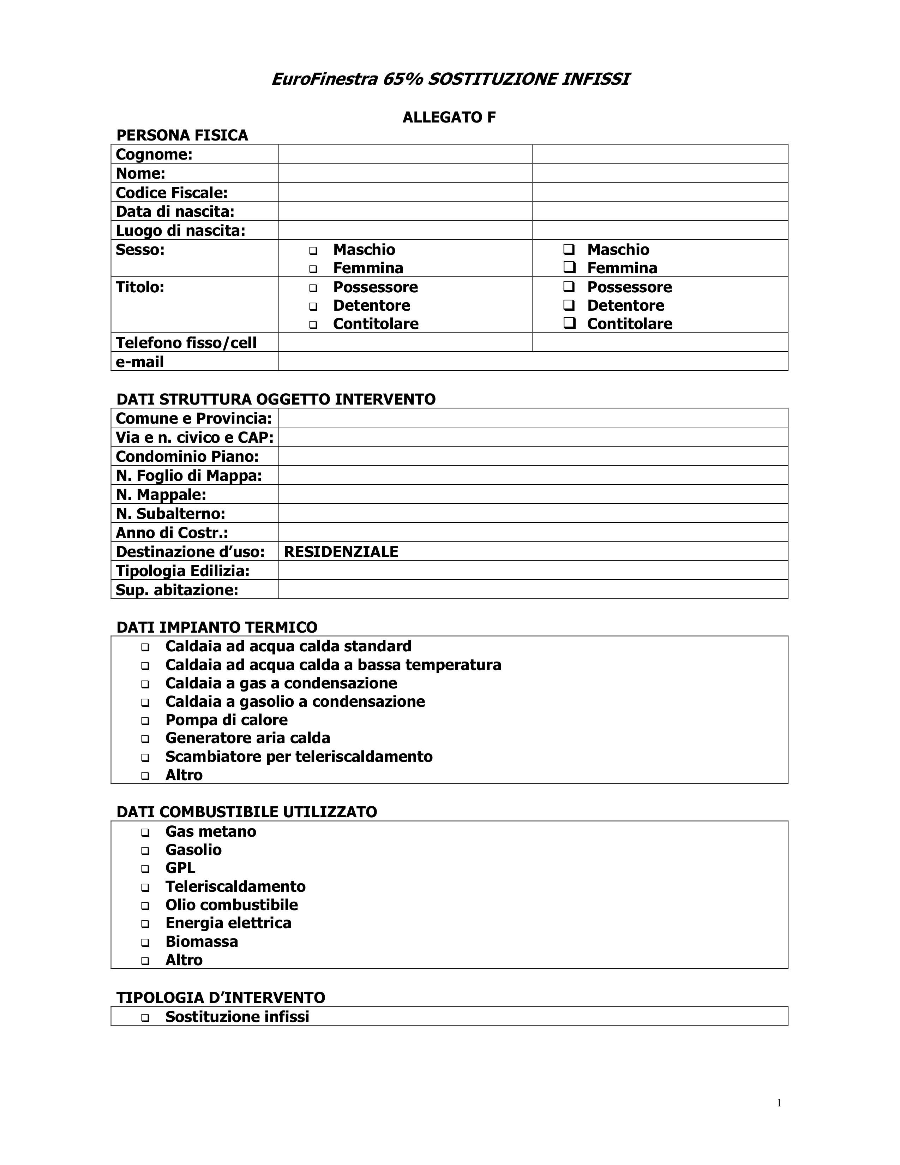

XXXXXX
XXXXXX
XXXXXXXXXXXXX
XXXXXXX
XXXXXXX
X

X

XXXXXXXX
XXXXXXX

XXXXXXXXX
XXXXXXXXX
XXXXXXX
XX
XXX
XX
XXXX

XXXXXXXXXXX
XXXXXX

X

X

X

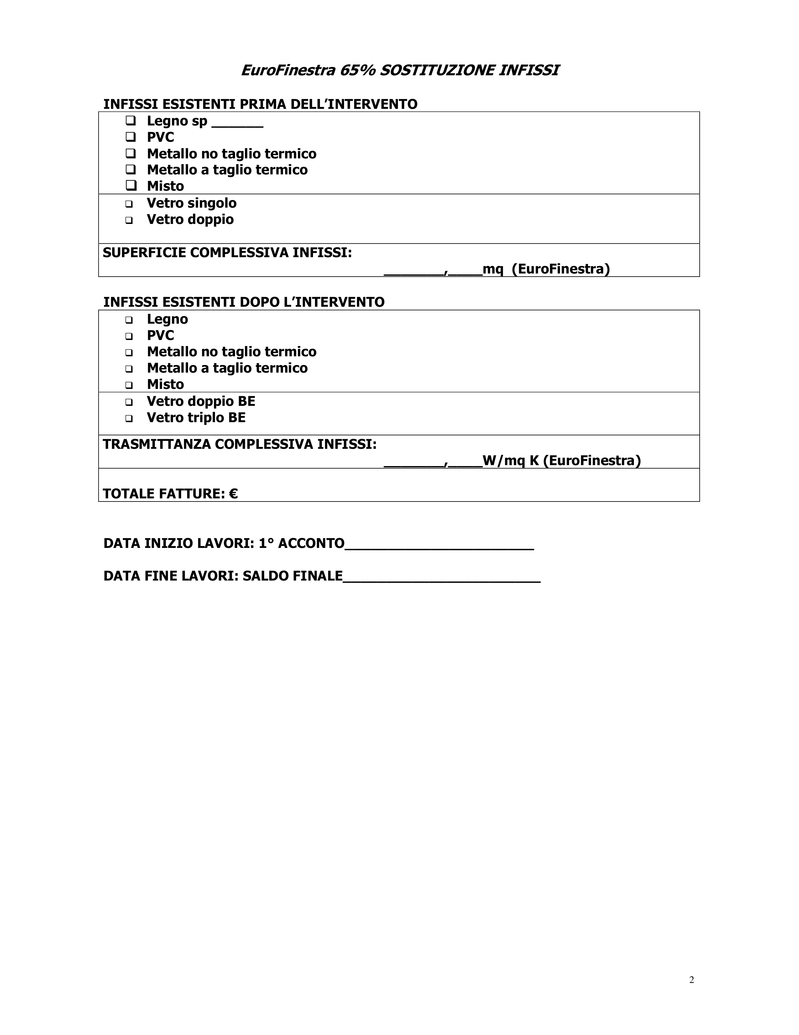

X

X

X

X

000,00

XX/XX/2014

XX/XX/2014

