Sling Blade was filmed in Benton, Arkansas
Let's try to use Google Maps to find the exact location of landmarks in the movie. We will start with the house.
Tell others about
this page:
↑ Like facebook Tweet twitter Submit reddit Share google+

Where was the house, in Sling Blade, located?
There are a couple of clues, in the movie, they reveal the location of the house used in the film.
First, when Carl and the boy (Frank) are toting laundry from the Econo-O-Wash to the boy's house, you can see a street sign that says "VINE ST" (see image right).
Later in the movie, you can see the house number (see image below-left).
By driving virtually, in Google maps, you can find that the house is located at the corner of Vine and South Main at: 522 South Main Street, Benton, AR 72015 (see image below-right).
As you can see, there is no longer a deck on the left side of the house (where Doyle's band played) and the left-neighbor's house is no longer standing. Last, you can't see any beer bottles sitting on top of a window-unit-air-conditioner (as in the movie), but that's the house!
alksdjfl aslkdfj lskdfj alkdsjf laskd lsajdlkadsj klasd
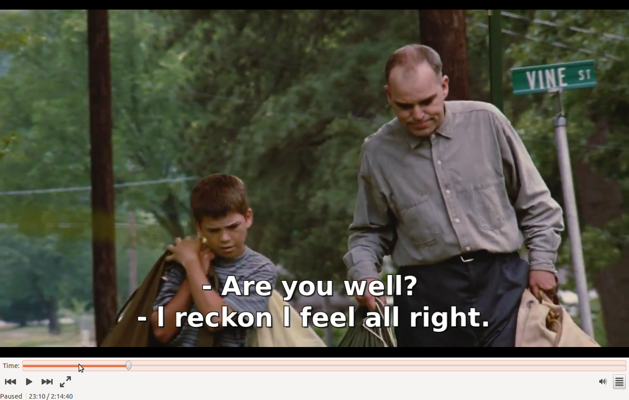
Stading outside the house, in the movie Sling Blade (notice "522"):
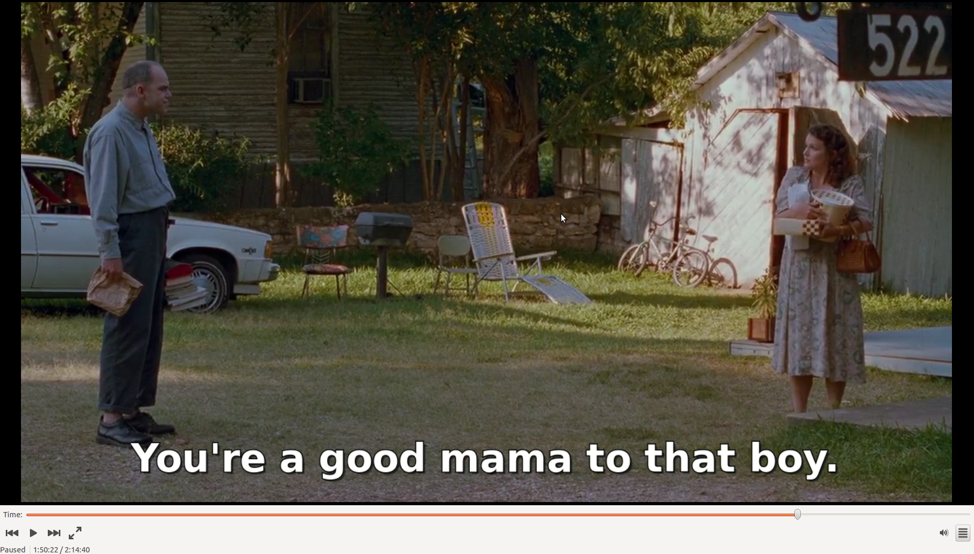
The house from Sling Blade on Google Map's Street-View:
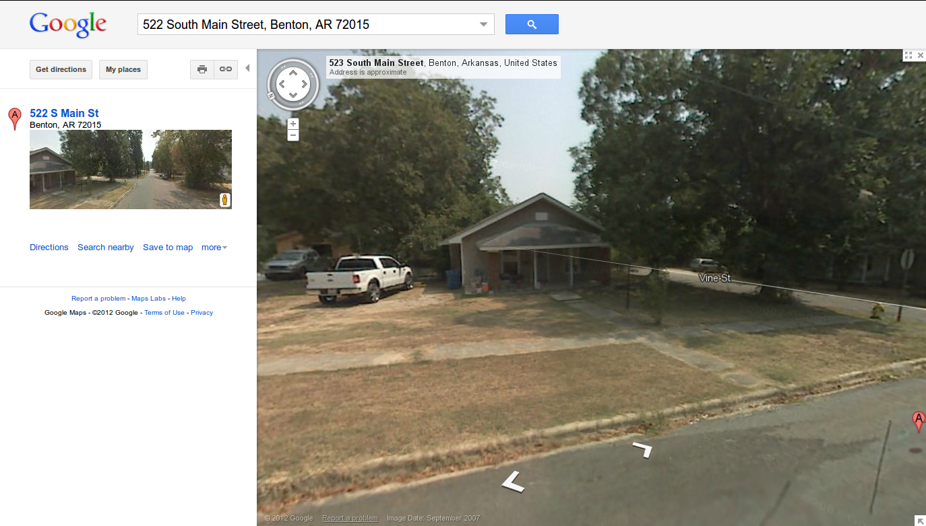
See on Google Maps

Where is Bill Cox's Repair Shop?
You can see in the image (right), how Bill Cox's Repair Shop looked in the movie Sling Blade. I set out to find its location on Google Maps, and here's how I found it.
In the movie, right before they arrive at Bill Cox's Repair shop (for the first time), the movie shows them passing through the intercection shown in the scene-still below. You can see several business on the right side of the road (many of which are no longer there). I was able to find that same intercection by virtually driving (via google street-view) down military road by those businesses (from that movie scene) that remain today. To the right of the movie-still (below), you can see that same intersection from Google Maps.
Right after their car passes through this intersection (coming toward you in the image in the images below), they take an immediate left right into Bill Cox's Repair shop. You can see their car (center) in the image below, and see it sitting in Bill Cox's parking lot (right) After they get out of the car, we get a close-up of the mailbox (see here), which has "1111" on it. So, Bill Cox's Repair shop was located at 1111 Military Road, Benton AR 72015.
Today, the property is occupied by a bank (see image).You can see that Google Maps marks Auto Zone right about where Cox's use to be; perhaps there was an Auto Zone there after Cox, but before the bank.
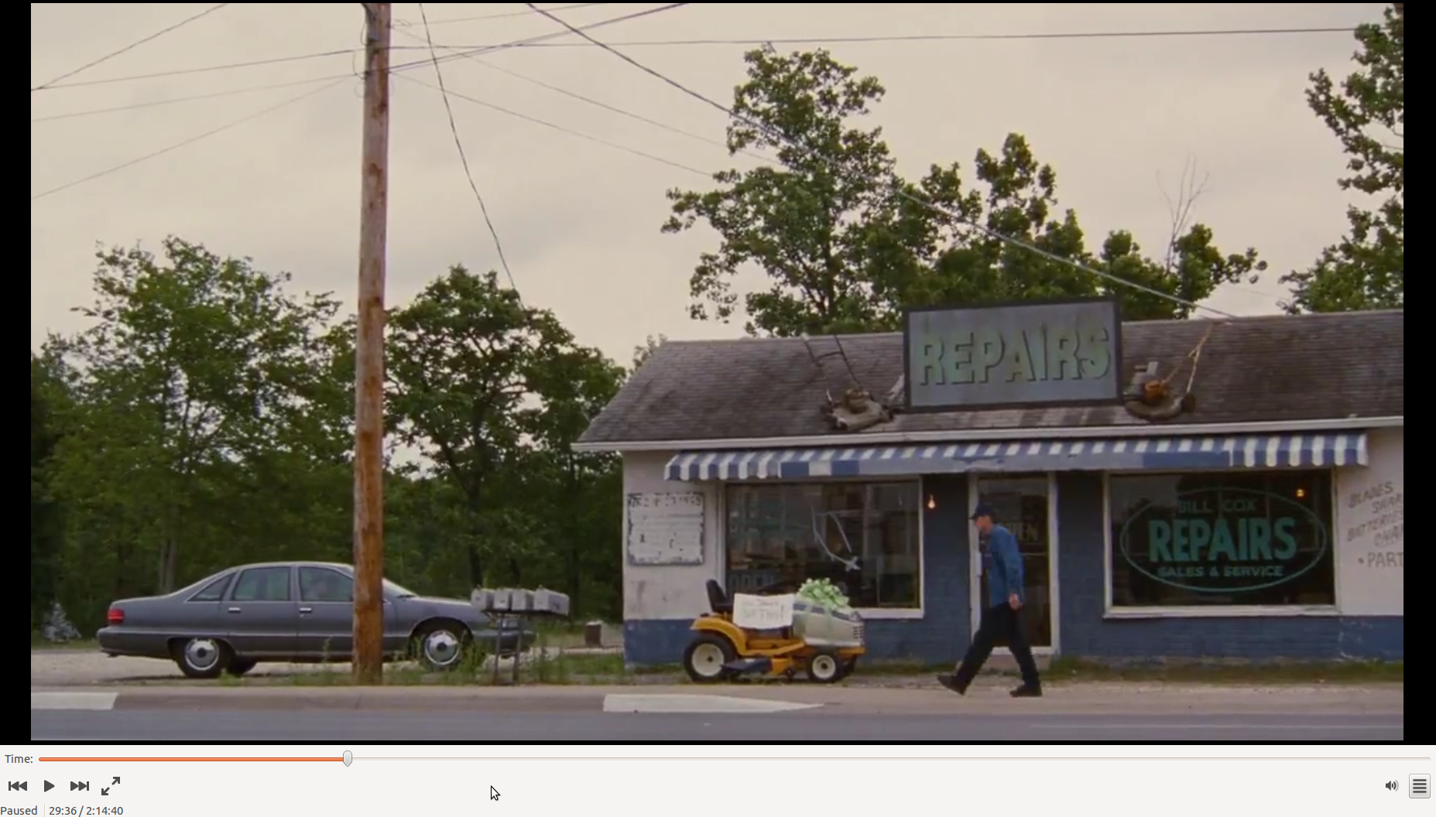
Ferguson Drive at Military Road from the movie Sling Blade (in Benton, AR):
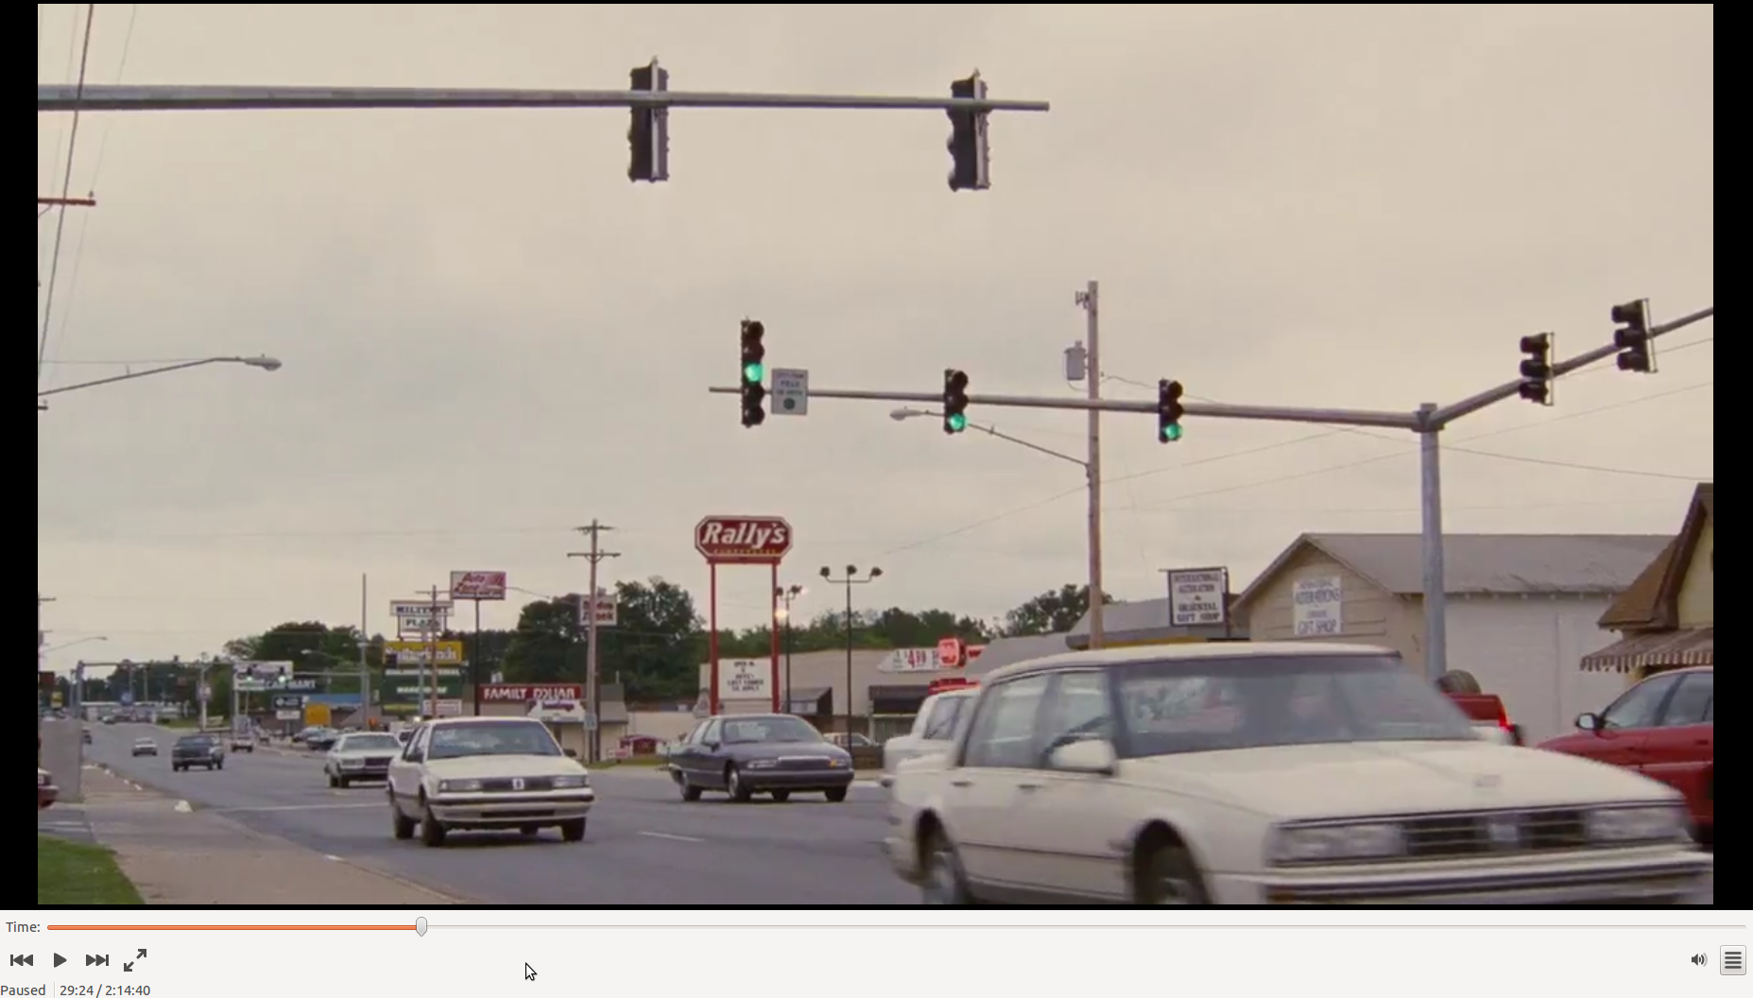
Ferguson Drive at Military Road from Google Map's Street-View:
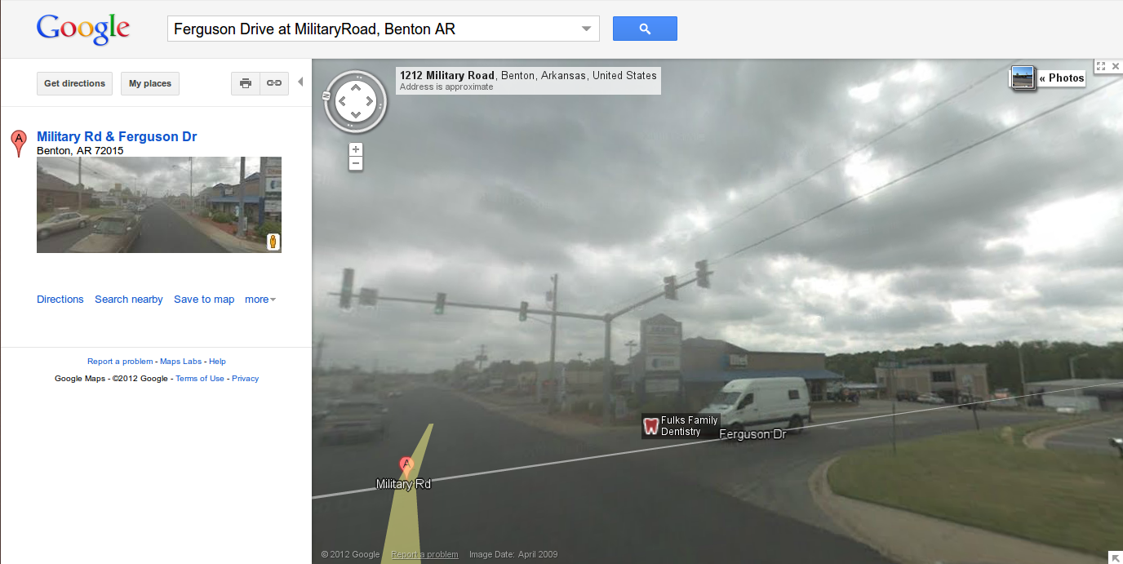
See on Google Maps

Where is the Econ-O-Wash?
I found the Econ-O-Wash, by using the "Search nearby" feature in Google Maps. I searched for "laundry" near the house's location. I find it interesting, that the Econ-O-Wash was actually in practical walking proximity (0.7 miles) just as portrayed in the movie.
Econ-O-Wash from the Movie Sling Blade (1032 Edison Ave, Benton, AR 72015):
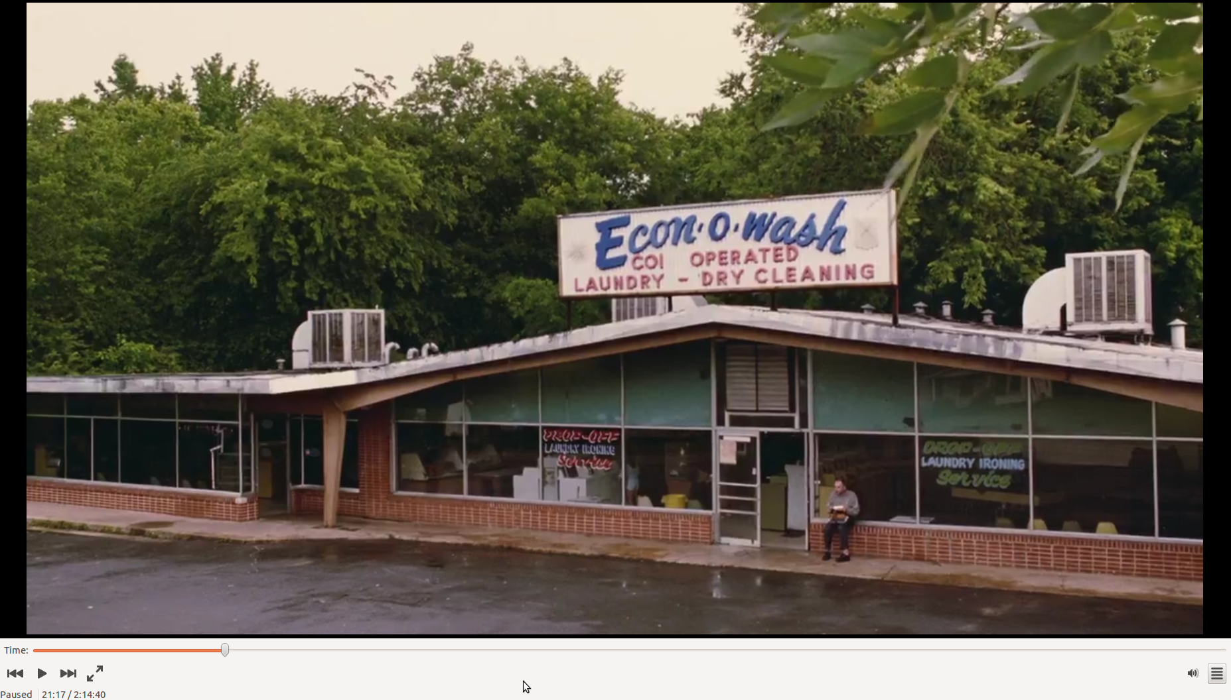
Econ-O-Wash is now the Fun Wash (remodeled):
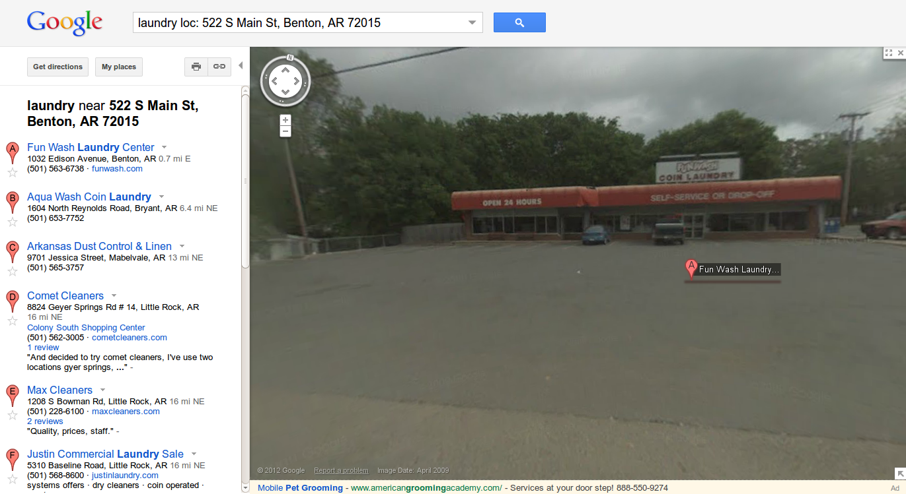
See on Google Maps

Where were Carl and Vaughan eating in that funny scene where Vaughan becomes disabused of his notion that Carl is a deep thinker?
If you look really close at the menu sitting in the background at their table, you can see they were eating at Gary's.
With a little help from Google Maps, I was able to find Gary's Drive-In at 673 Cox Ave, Benton, AR 72015 (see image below-right).
Cox Ave.? Could this street have been name after Bill Cox (or someone in his family)?
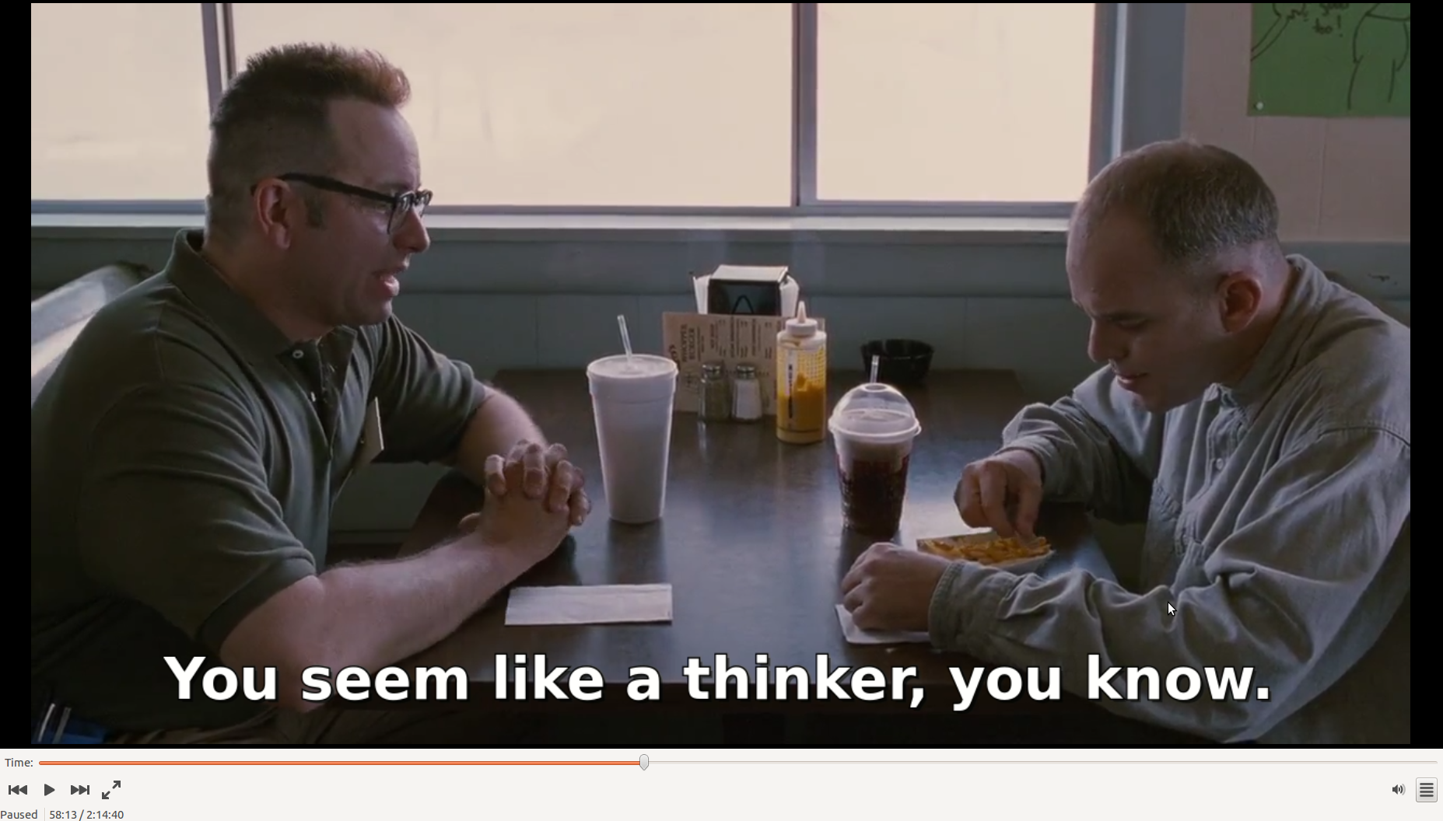
Gary's drive-in from the movie Sling Blade (in Benton, AR):
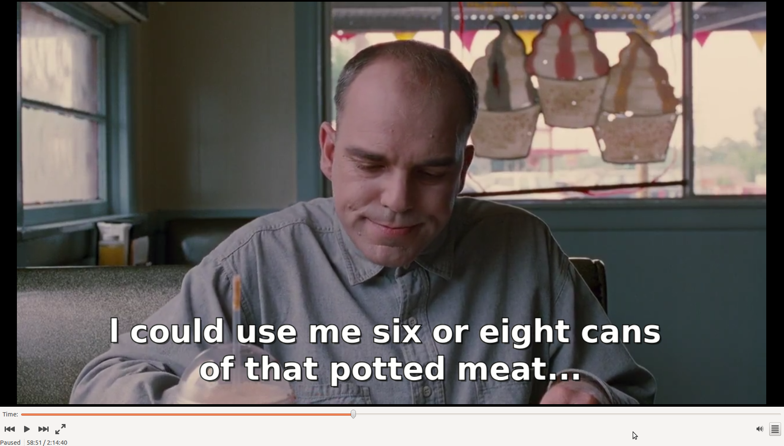
Gary's drive-in from Google Map's Street-View:
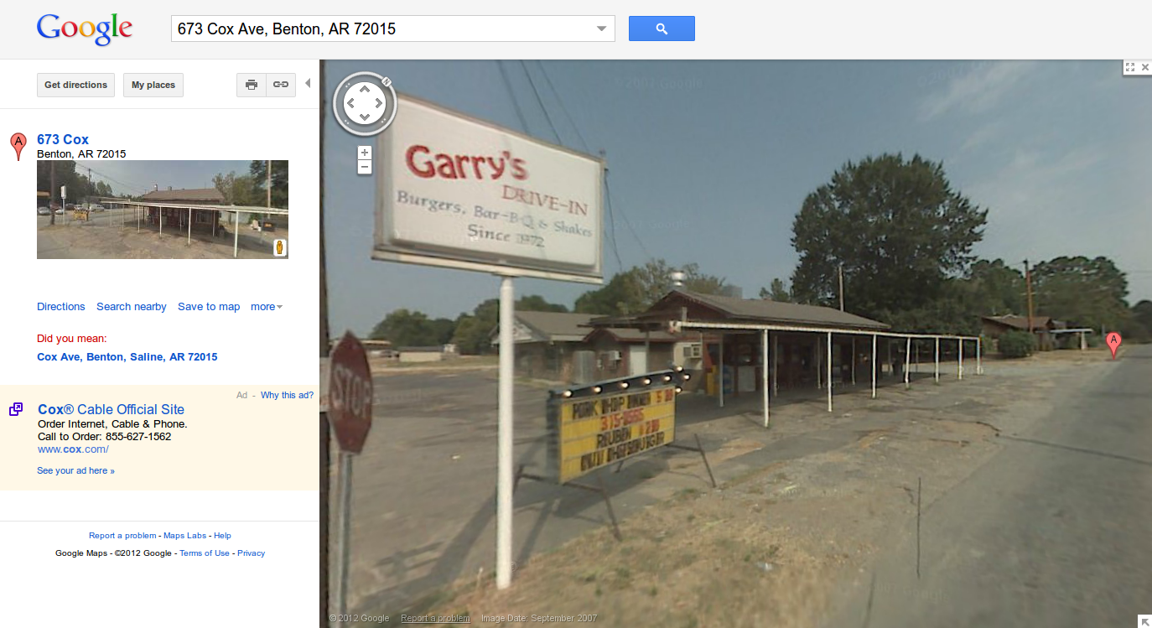
See on Google Maps
Bill's Barber Shop from the movie Sling Blade (in Benton, AR):
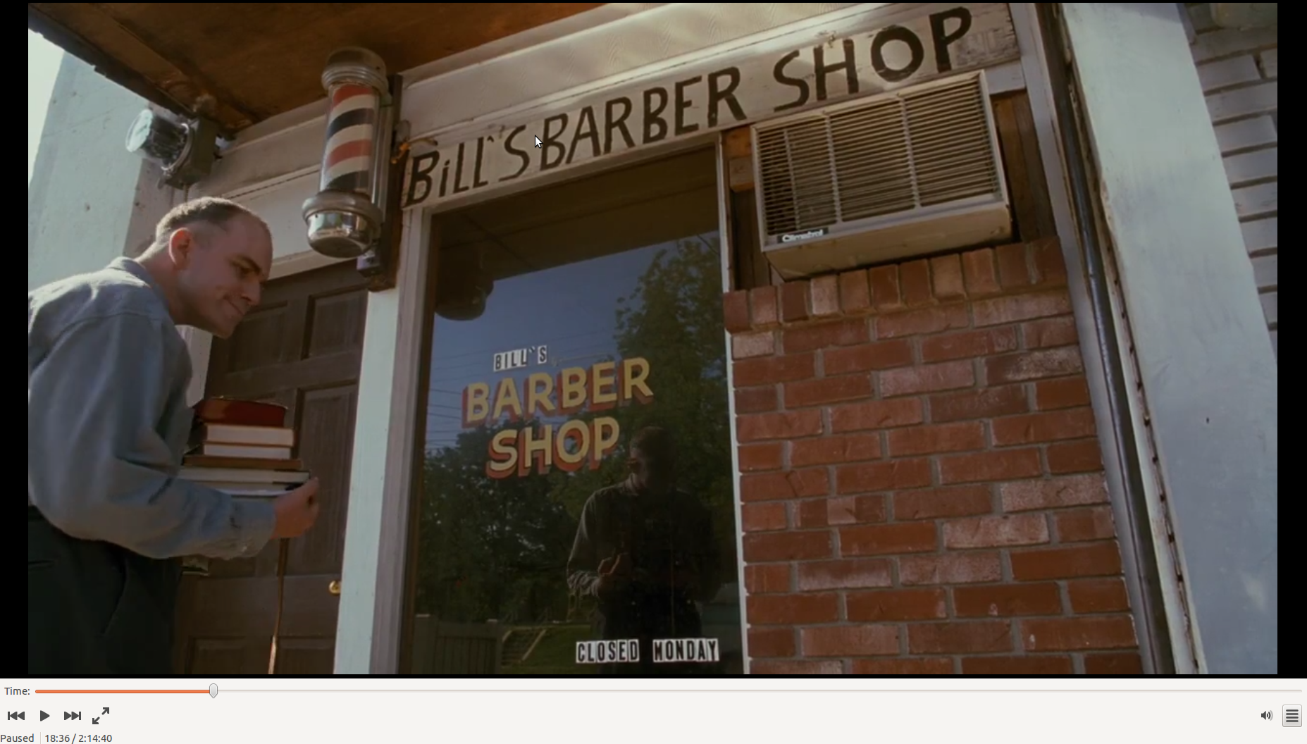
Bill's Barber Shop from Google Map's Street-View (Greg Sams' Shaggy Dog Pet Salon):
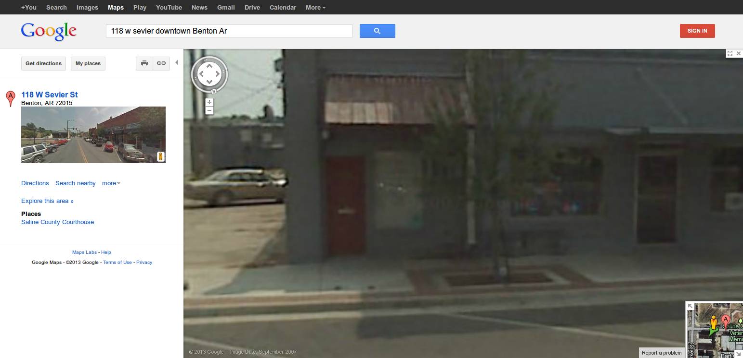
See on Google Maps

Places I couldn't find on Google Maps:
- Frosty Cream (Is that a Dairy Queen sign profiled in front?)
- Hoochie's Dollar Store
- Bill's Barber Shop - Update: Found by Greg Sams on 05-02-2013 (now included above)
- Carpet Cleaning Place
- Police Building
If you're able to locate these places, drop me a line here.
Tell others about
this page:
↑ Like facebook Tweet twitter Submit reddit Share google+

