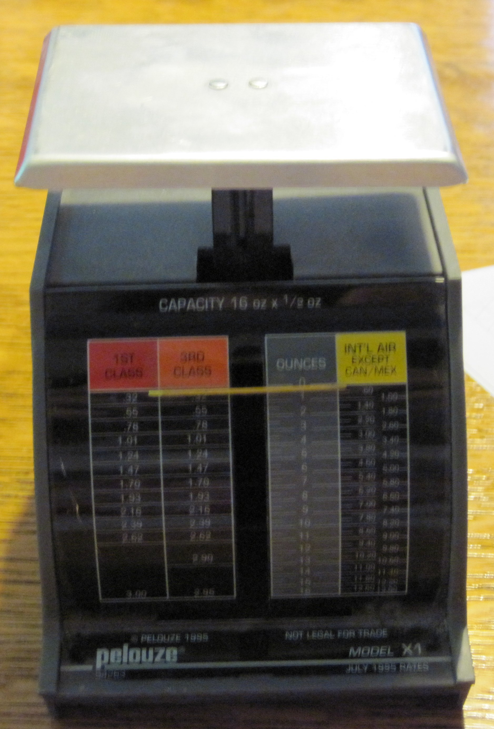Illustration 1: Frontal View
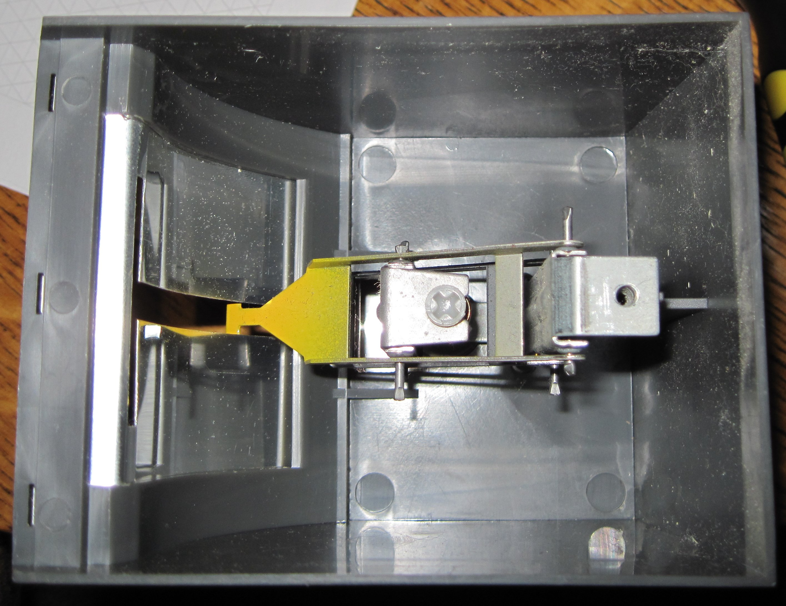Illustration 2: Bottom View, Interior

A: Illustration 1: Postal rates are fixed and cannot be changed.
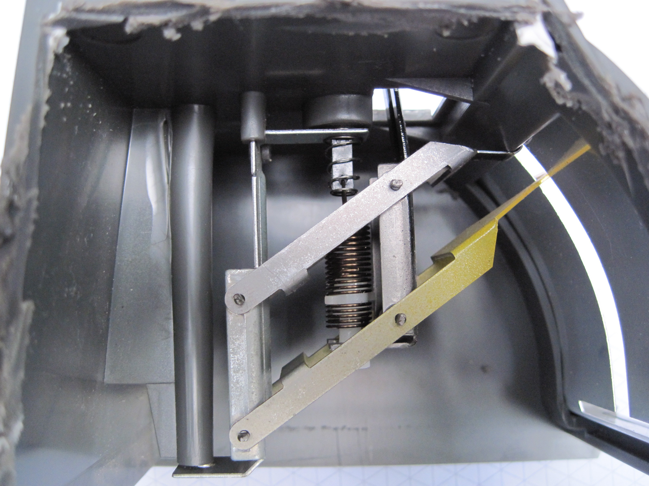Illustration 3: Side view, Interior
B: Illustration 1: Design is not pleasing to the eye, and does not look modern.
C: Illustration 2,3: Internal mechanics are weak and loosely attached. They go out of alignment if the device is dropped.

Title: Product Improvement Project, Pelouze Model X-1 Postal Scale
Designer: Rachel Brill
6/04/2009
DDP Period 4
Product Improvement Design Brief

Client Company: | Pelouze
Designers: | Rachel Brill
Problem Statement: | Overall the design appears like a disposable product. The design of the scale is flimsy and easily falls out of calibration. The appearance is unappealing and not modern. The postal rates are fixed and are not changeable. During a period of when postal rates are raised yearly this makes the product rapidly obsolete.
Design Statement: | Design a new postal scale that will be more appealing to consumers and appear sturdier. Consumers should be able to easily replace the postal rates card.
Contraints: | Cost to consumer cannot exceed $10.

Conclusion Questions
- What factors must be considered when changing or enhancing a design?
  - Difficulty or complexity of design change
  - usability to consumer
  - attractiveness to consumer
  - effect on product life-span
  - impact on safety
  - time it will take to develop a new design versus market demands
  - cost of design enhancement

- Why is important to document the entire brainstorming process and not leave out any ideas?
Because it can be difficult to determine what is a good idea until you have viewed them all and evaluated them. Also, one idea will sometimes lead to more ideas, or an earlier idea may end up being better after more thought and feedback.

- What is the purpose of sketching your ideas?
Visualizing ideas is often a good communication tool. Also in product design it is very important to understand how things fit in space and that is often unclear from verbal descriptions.

