OpenERP v6 new finance reports testings
done by : Frederic Clementi
Date : 26/08/2010
database : openerp6dbreport on localhost:8169
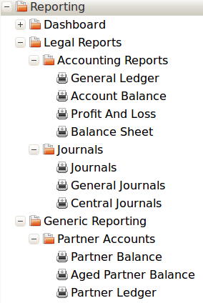
tested reports :

Senario :
- Test done over 3 fiscal years : 2008, 2009 and 2010
- Fiscal Year 2008 has been closed
- Opening entries posted on 1/1/2009. No opening entry in 2010
- 4 customers invoices and payments have been created :
  - 01/03/08 – Invoice to Frederic for 5380 F ttc partially paid on the 20/08/2010 for 2500F
  - 01/08/2009 - Invoice to Nicolas for 2152 F (no vat) paid on the 20/08/2010
  - 20/08/2010 - Invoice to Nicolas for 1076 F ttc paid on the 20/08/2010
  - 20/08/2010 - Invoice to Joel for 100 F ttc paid on the 20/08/2010

Before testing these reports, we wish to make a 2 comments on chart of accounts view (in accounting / Charts / Charts of accounts).
1 - Filter on fiscal year is not precise enough. It is very important to have the ability to select a period instead of simply a fiscal year. I.e : if we choose May-09 then we want to see accounts balance from 1/1/2009 and up to the 30/05/2009 (all entries after that day excluded).
2 – We also need a checkbox to add initial balances for balance sheet accounts (if opening entries have been already posted or not). If you want to see your chart of accounts view for May-09 only for instance you might want to see initial balance as well.

General Ledger
Printout – year 2008
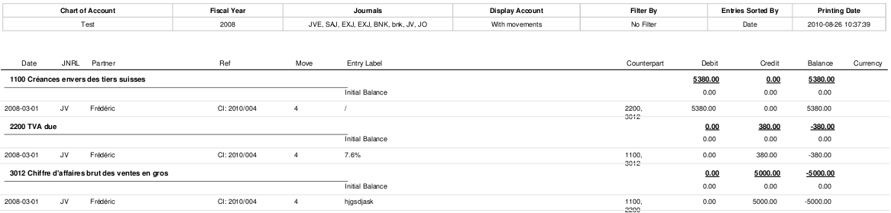
Printout – year 2009 – Before 2008 closing
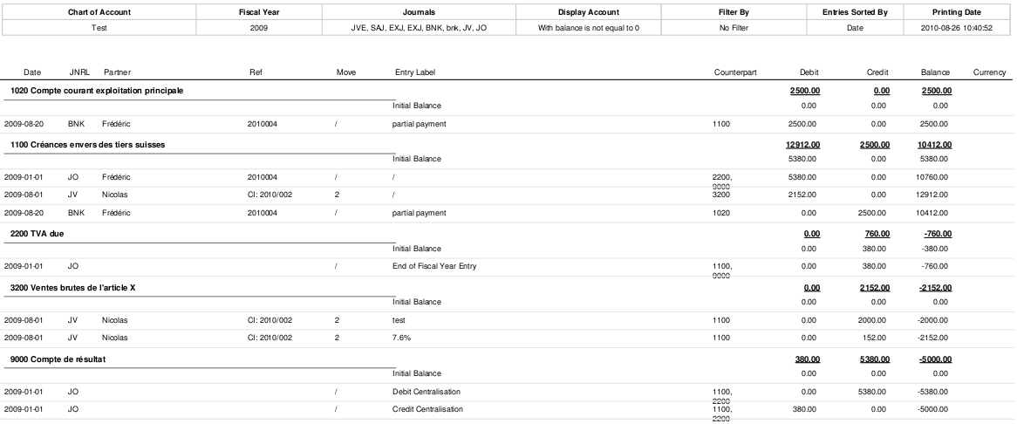
Printout – year 2009 – After 2008 closing
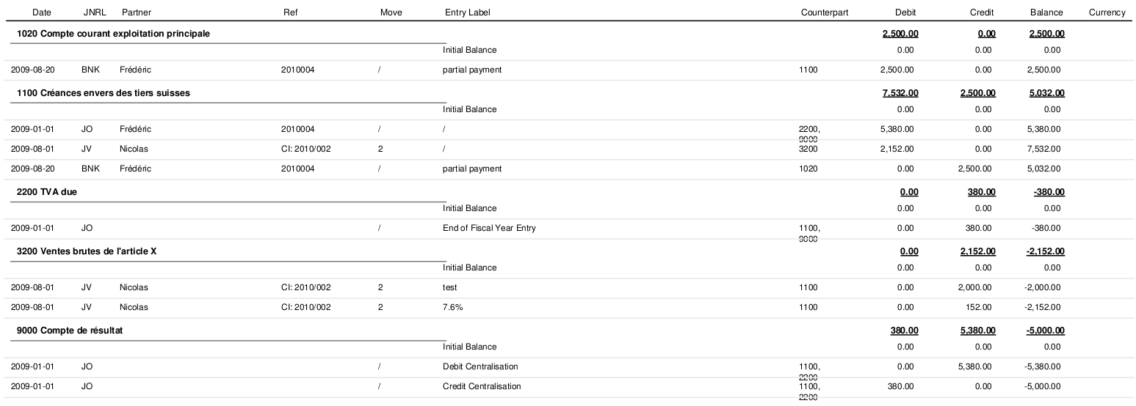
Printout – year 2010
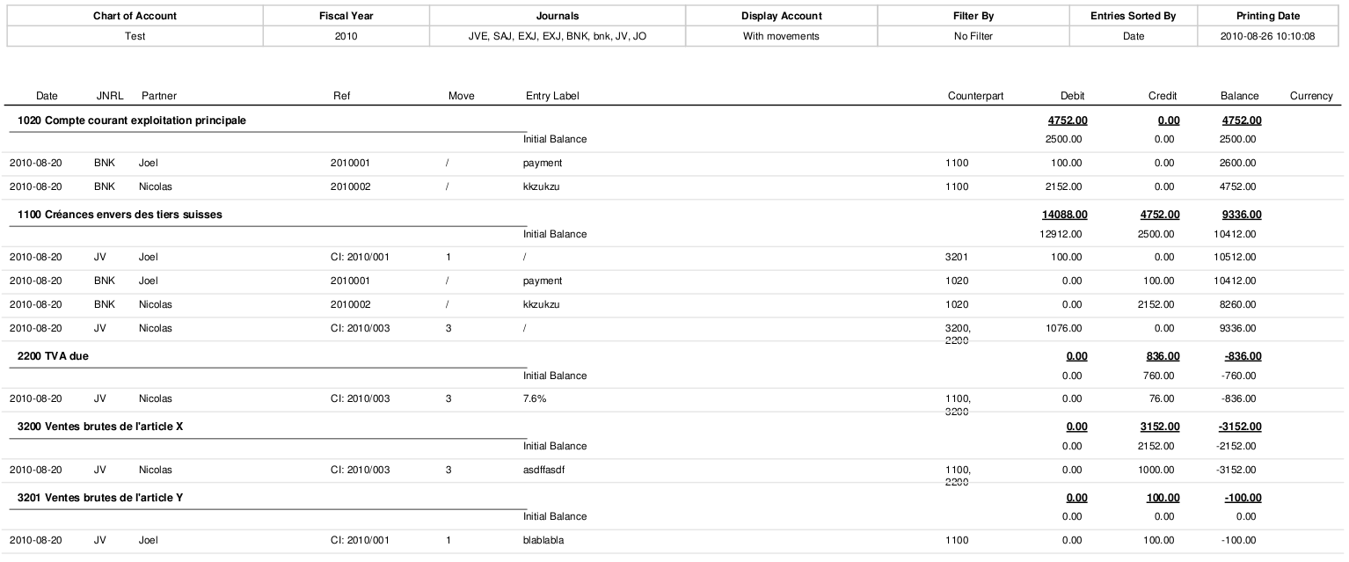

Layout :
- Credit, Debit and Balance Totals should be at the bottom of the columns instead of the top.(confusing). It would improve reading quality (more space between accounts).
- Totals should not be underlined (not clear) – Just using Bold is better.
- Columns « counterpart » : all accounts should appear on the same line (instead of below the previous one) and we must have a max of 5-6 accounts (if more use « ... »).
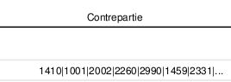

- Layout problem when account description is long : (see below)
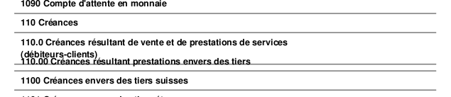
Data :
- Whenever opening entries have been generated, the previous fiscal year is not closed yet, and the user ticks the initial balance checkbox then the report is wrong (balances brought foward appear twice).

Checkbox « initial balances » should not test if the fiscal year is closed or not ; the test has to be on the opening entries posting instead.
* If we have opening entries (OP) during the fiscal year selected then the report must not show initial balances (IB)
* If we do not have OP then IB must be calculated (from beguing of fiscal year for P&L accounts and from last OE during previous fiscal years for B/S accounts)
This way of doing will allow final users to decide if they want to generate opening entries or not (which is possible is report always includes initial balance)

Now, there is an other specificity quite important : when using filter (by date or by period)
* 1st comment : we do think that the Start date or the Start period are very useful and in order to simplify the report coding we could assume that the start date/period could not be prior to the fiscal year selected above.
* 2nd comment : If the GL report is filtered from march to april (knowing that fiscal year starts 1st of January), we need to have initial balances up until the end of February. The tricky thing will be to manage whether we have or not opening entries.

Conclusion : the checkbox « include initial balalance » must not generate a wrong report with a doucle count on the balance brought foward.

- Periods filter is bugged.
- This report should give the possibility to select one account or a range of accounts (or even better if possible any selected accounts)
- This report should give the possibility to select « All entries » or « Posted entries » like in the account chart.

- Regarding foreign currencies amounts columns :
1- In case of invoice with foreign currency it would be much better to add the currency code beside the amount in currency instead of below like in this printscreen :
- We need to add a column « cumulative balance in Currency » for currencies amount.
- Column « balance in Currency » and « cumulative balance in Currency » should have totals (except in case of multiple currencies)

Performance:
Pdf is really too slow to appear on the screen. With a instance installed on my PC the following performance have been recorded: (test based on fiscal year 2010 – 5 entries only)
* 38s - filtered on display accounts: with mouvement
* 1min 42s - filtered on display accounts: All

Account balance
Printout – year 2008
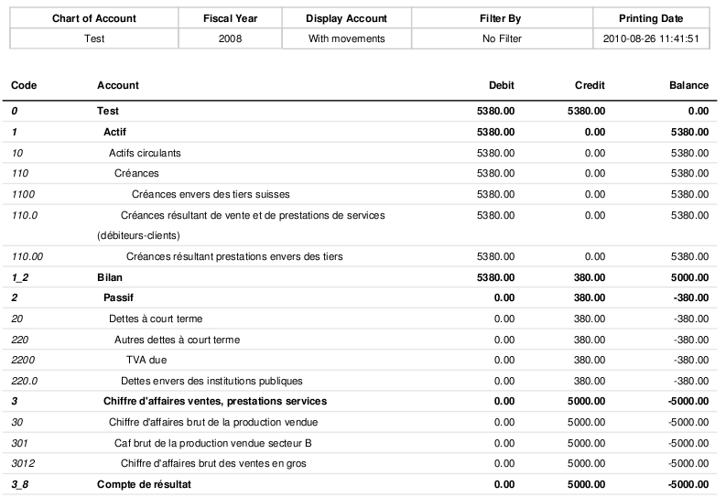
Printout – year 2009
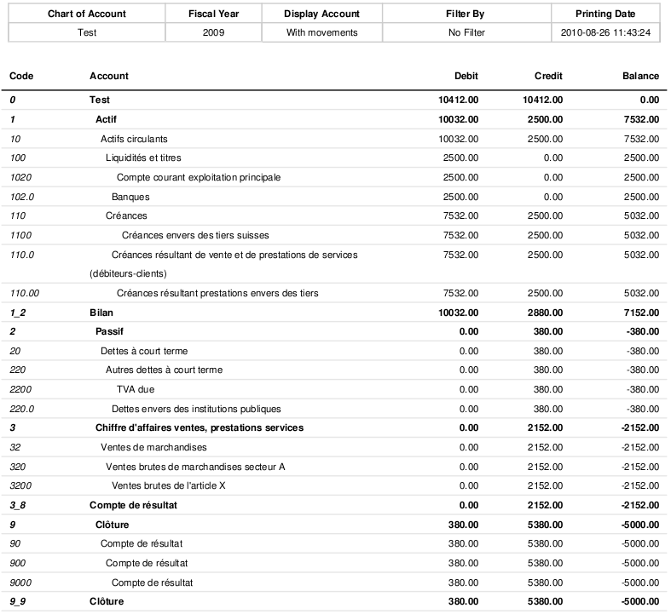
Printout – year 2010

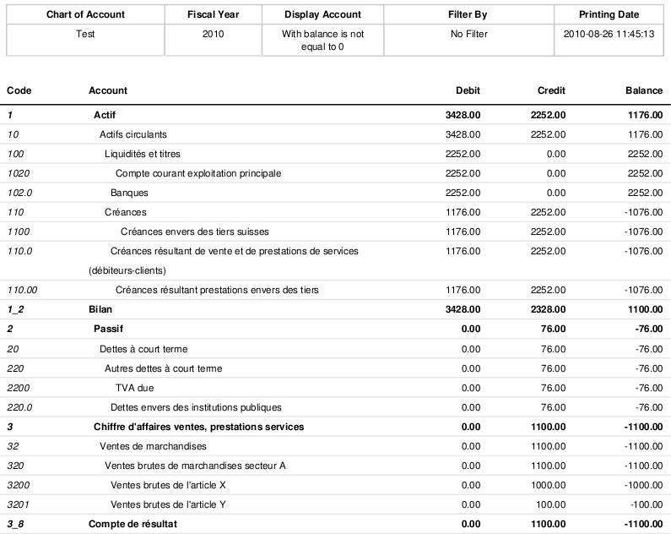
Data:
- In order to be concistent with GL report and due to the filters, we have to add an « initial balance » checkbox. When ticked, balance sheet accounts include initial balance in their balance in case opening entries were not posted yet. Be carefull to include initial balances in each account individually and not a simple line at the beguinning of the report wich would be pointless.
- Bug : Impossible to filter by period, the following message is displayed :
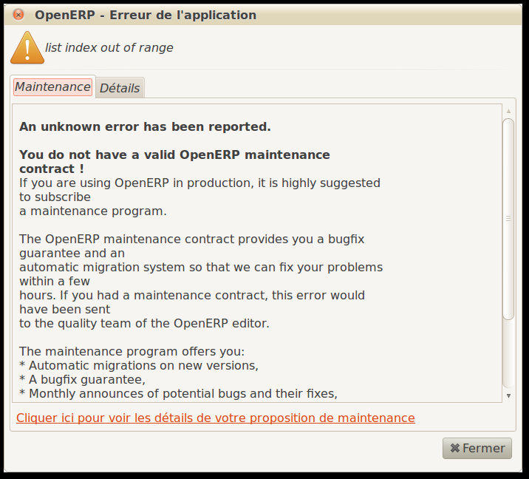

Layout:

- The report should be renamed : « Trial balance ».
- Please put in bold view accounts
- It would be great to be able to choose to see the trial balance with or without view accounts. (In my opinion, I think that view accounts here make the information more difficult to find but other people might appreciate it).
- The accounts order is not in line with the Chart of account order. In other words, parents ID are not correctly used. I.e : line « 1_ 2 Bilan » or « 220.0 »
- This report should give the possibility to select « All entries » or « Posted entries » like in the account chart.
- Need to add the checkbox « with currency » like for the GL report. In the printout, we need to add 2 columns : balance amount in currency and currency code (i.e : EUR)

Profit and Loss
Printout – year 2008
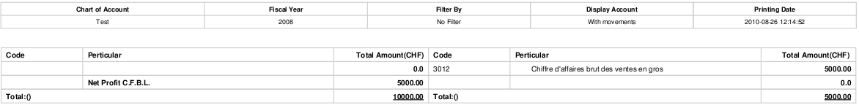
Printout – year 2009
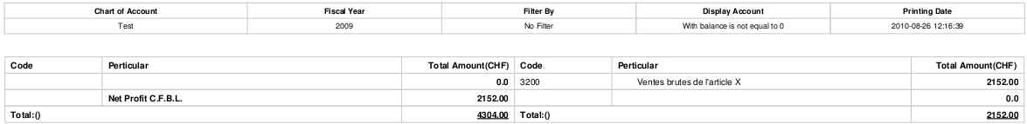
Printout – year 2010
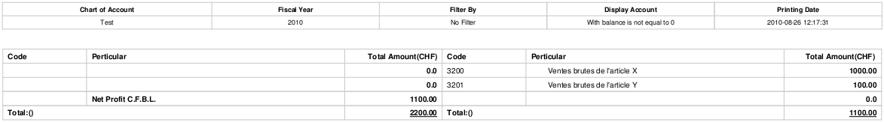

Layout :
- Line « Total:() » should not includes Net profit CFBL amount.
- Bug : Impossible to filter by period (same as in account balance report – see above)
- Should includes accounts 9xxx as well (closing centralized accounts in swiss CoA)
- Line called « profit CFBL » has to be named « Profit /Loss »
- Line called Total:()has to be named « Total »
- Col. « Pertuculiar » should be named « account name »

Data:
- This is not a P&L report. It is only a trial balance that separate Revenue and expenses.
- This report should inludes view accounts (in bold) to become a kind of very detailed P&L
- This report should give the possibility to select « All entries » or « Posted entries » like in the account chart.
- This report must treat the initial balance/opening entries problem (see above in GL reprt)

Balance Sheet
Layout :
- Bug : Impossible to filter by period (same as in account balance report – see above)
- Do not understand the point of selecting surplus account.
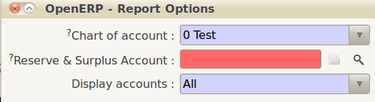
- « Surplus » should be renamed « profit/Loss »
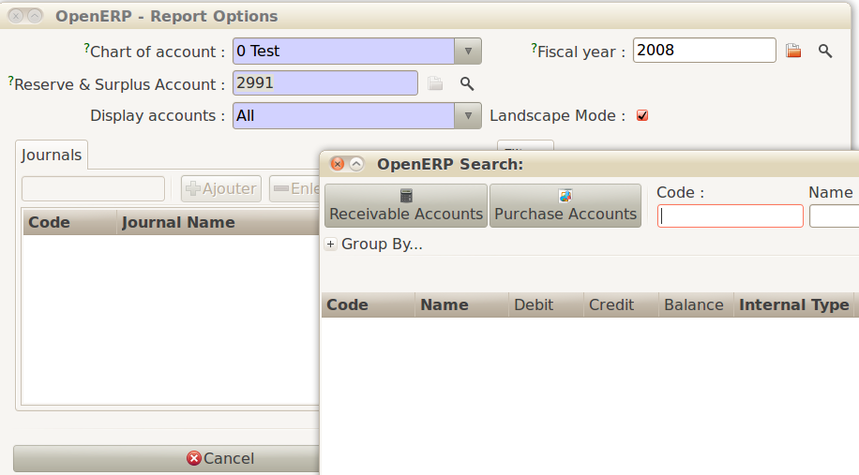
- My profit account is not accepted and a strange window is opening with selection buttons on Receivable or Purchase accounts (?)
- Report can be executed if creating a dummy account from this window.
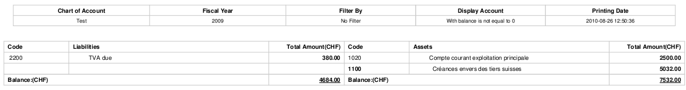

Data:
- This is not a balance sheet report. It is a trial balance with a split between Assets and liabilities.
- Assets should be on the left and liabilities on the right
- This report should inludes view accounts (in bold) to become a kind of very detailed B/S
- This report should give the possibility to select « All entries » or « Posted entries » like in the account chart.
- This report must treat the initial balance/opening entries problem (see above in GL reprt)

Journal
Printout – year 2009 – Sales journal
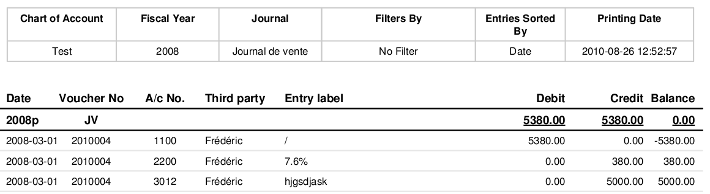
Layout:
- Column « Balance » has to be deleted since it is pointless on this report (since we have various accounts)
- Totals should be at the bottom of the report
- Move No and account name are missing
- This report should give the possibility to select « All entries » or « Posted entries » like in the account chart.

General Journal
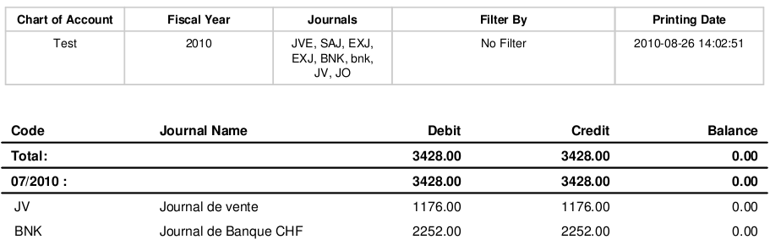
- I do not understand the purpose for this report. Not necessary in my view.

Central Journal
- I do not understand the purpose for this report. Not necessary in my view.

Partner balance
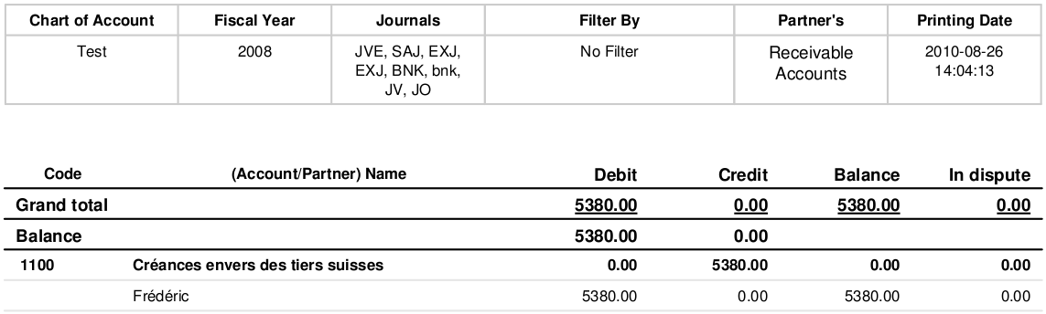
Printout – year 2008

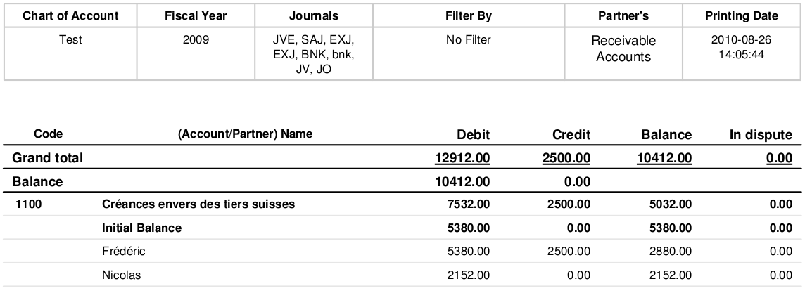
Printout – year 2009

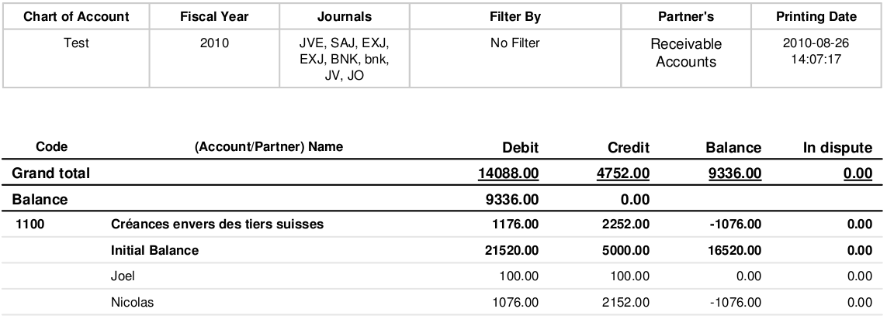
Printout – year 2010

Layout:

- Grand Total should be at the bottom of the report
- Line called « balance » is pointless since we already have a column called balance. To be deleted.
- Col. Debit and Credit are not useful in my opinion, col. Balance is the only one relevant. We should delete or hide these 2 col. and the relative grand total line.

Data :
- If the 2008 printout (see above), the amount on the account 1100 should be a debit. Strangely, in 2009 report, it is correct.
- Initial balance has to be treated like for the trial balance. It is wrong to create a line called initial balance since the initial balance has to be included individually in each partner accounts. Plus, like for the GL report we have to test if we have opening entries or not. Finally, the report must work with the filter (see my example in GL report). Again, as said for the GL report, from a business perceptive teh start date/period in the filter is not relevant but we want to keep the same filter mask I guess to be as generic as possible and this is why the initial balance checkbox is necessary here as well.
- This report should give the possibility to select « All entries » or « Posted entries » like in the account chart.
- This report should give the possibility to select « Partners with mouvement / balance <> 0
- It is very important that you can print one or several Partners.

Partner ledger
Printout – year 2009
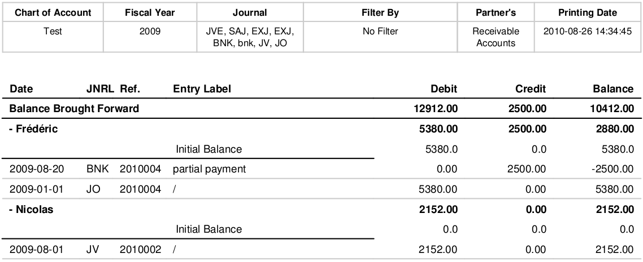

Printout – year 2010
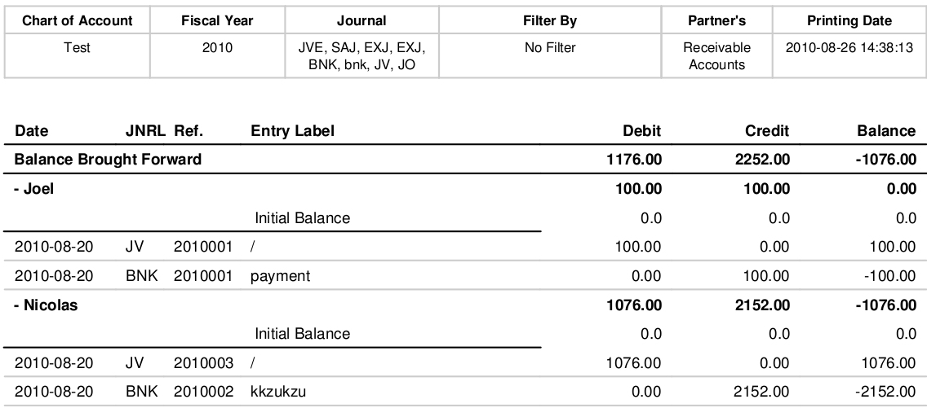

Layout :

- Balance brought fwd and initial balance lines should be deleted.
- col missing : move no, account no, account name
- This report should give the possibility to select « All entries » or « Posted entries » like in the account chart.
- Please add a sort on date
- In case of invoice with foreign currency it would be much better to add the currency code beside the amount (last col.) in currency instead of below like in this printscreen :
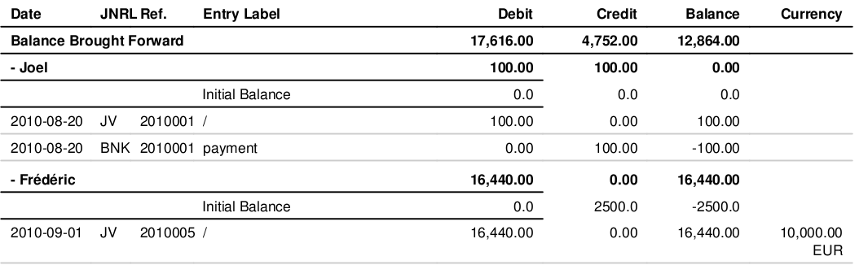
on top of this, we should have a total in currency for the currencies amounts as well (unless we have a mix with several currencies.

Data :
- Initial balance problem : due to the fact that opening entries related to patners can be reconciled or not we cannot manage this issue the same way. We suggest that for this specific report, opening entries are systematicly ignored. This means that initial balances has to be always calculated when checkbox is ticked. That suppose obviously to create the initial balance check box and probably (let us know what you think) to delete the recouncile entries checkbox.
It is important to keep in mind that the report can be printed from March to April in which case we should see the initial balance up until end of February.
- This report should give the possibility to select « All entries » or « Posted entries » like in the account chart.
- This report should give the possibility to select « Partners with mouvement / balance <> 0
- It is very important that you can print one or several Partners.

Aged Partner balance
Printout – year 2008 - date 1/06/2008 - option: past
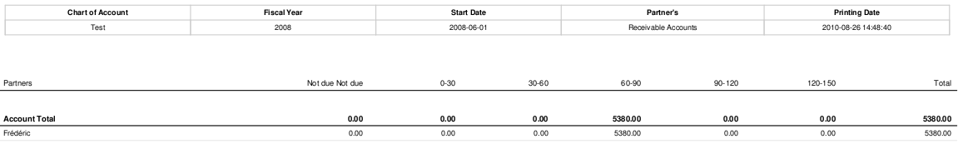
Printout – year 2008 - date 1/06/2008 - option: future
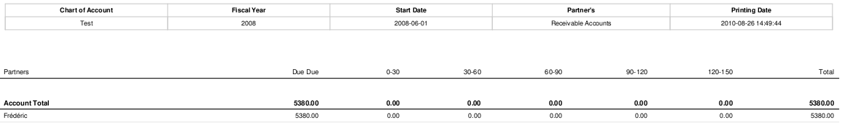

Printout – year 2009 – date 01/10/2009 – Option: Past

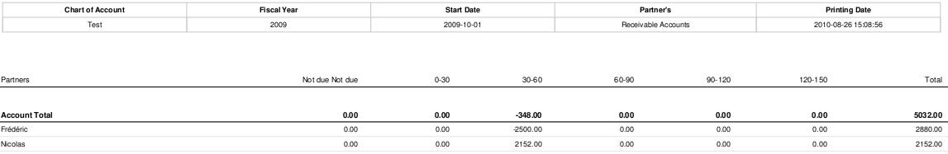

Layout :

- Col. « not due » : it is written twice
- Col. « 120-150 » should be « >120 » , it is possible to have an invoice due for more than 150 days.
- Col. « total due » should be on this report. I suggest that we keep the 4.2 version layout (or at least the order of the col.)

- This report should give the possibility to select « All entries » or « Posted entries » like in the account chart.
Data :
- This report has to be based on maturity date instead of invoice date. Goals of this very important report are to chase payment, to calculate provision on receivables, to known which supplier invoices have to be paid or to make cash forecast.
- Nice to have : This report should give the possibility to get all unreconciled invoices as well (=more details). This is very usefully when the accountant has to chase payement for exemple. This would be an option of this report.
- This report should give the possibility to select « All entries » or « Posted entries » like in the account chart.
- This report should give the possibility to select « Partners with mouvement / balance <> 0
- It is very important that you can print one or several Partners.

