1 Environment config

cinder.conf
[root@node01 ~]# cat /etc/kolla/cinder-volume/cinder.conf
[DEFAULT]
。。。。。。。
enabled_backends = rbd-1
。。。。。。。。

[rbd-1]
rbd_ceph_conf = /etc/ceph/ceph.conf
#rbd_user = admin
backend_host = rbd:volumes
rbd_pool = volumes
volume_backend_name = rbd-1
volume_driver = cinder.volume.drivers.rbd.RBDDriver
#rbd_secret_uuid = 8f6ad9e0-719d-4101-a432-f3e7f04852e5

#[lvm-1]
#volume_group = cinder-volumes
#volume_driver = cinder.volume.drivers.lvm.LVMVolumeDriver
#volume_backend_name = lvm-1
#iscsi_helper = tgtadm
#iscsi_protocol = iscsi

2. nova.conf
[root@node01 ~]# cat /etc/kolla/nova-compute/nova.conf
[DEFAULT]
。。。。。。。

[libvirt]
connection_uri = 。。。
inject_passwoed = true
inject_partition = -1
#rbd_secret_uuid = 36941069-a4e5-43fa-a4c5-423b8a10eb8f
images_rbd_pool = vms
images_type = rbd
images_rbd_ceph_conf = /etc/ceph/ceph.conf

。。。。。。

ceph.conf
The config in docker of cinder_volume and nova_compute and glance_api.

[root@node01 ~]# docker exec -ti -u root cinder_volume bash
(cinder-volume)[root@node01 /]# cat /etc/ceph/ceph.conf
[global]
fsid = fe234852-de48-3efc-9879-bf59ebdf4b5a
mon initial members = node01,node02,node03
mon host = 192.168.2.180,192.168.2.181,192.168.2.183
auth service required = cephx
auth cluster required = cephx
auth client required = cephx
auth supported = none
rbd default format = 2
rbd default features = 1
osd pool default size = 2

2 Process description
- Create a bootable volume.
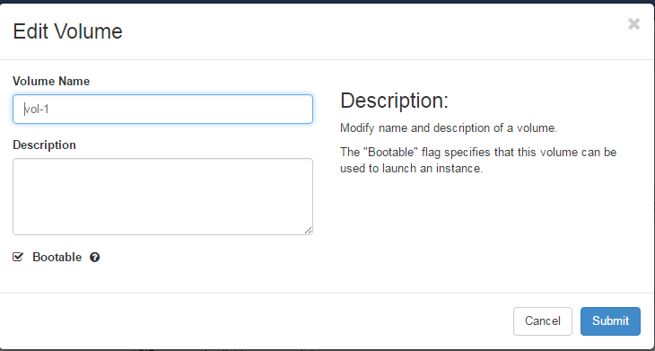
- Use this volume, lanch a instance.
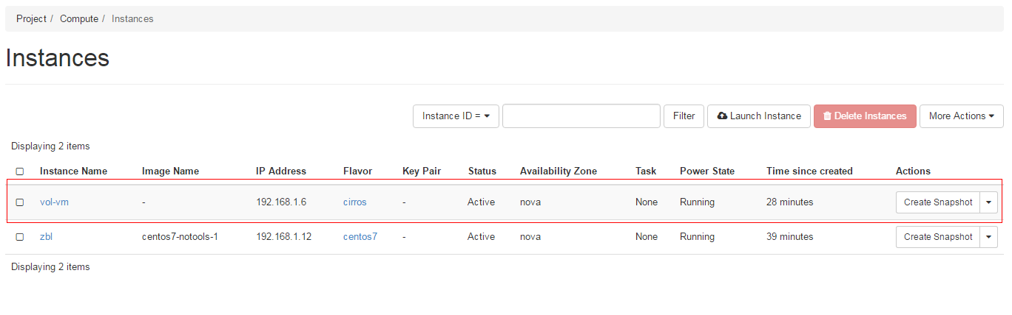
- Use this instance, to “Create Snapshot”, then go to images
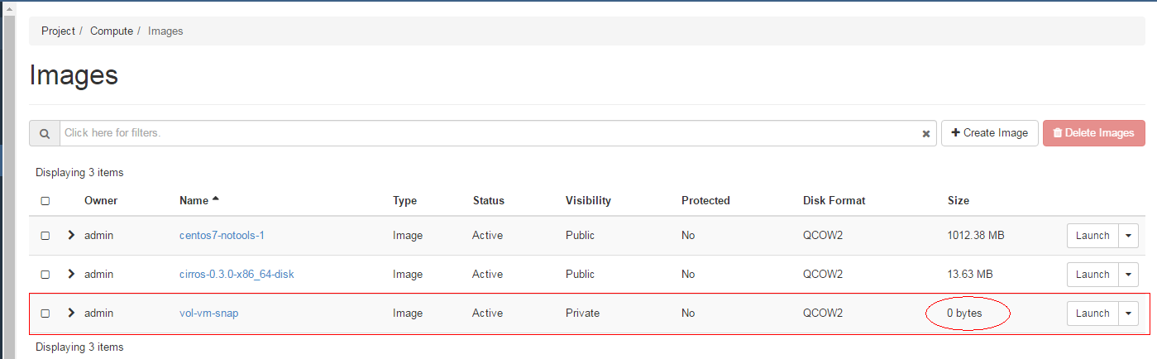
The vm’s snapshot is 0 bytes. You can use this image(or snapshot) to create a instance or volume, it will be failed.
ERROR:
- Use this 0 bytes image(or snapshot) to lanch a instance failed.
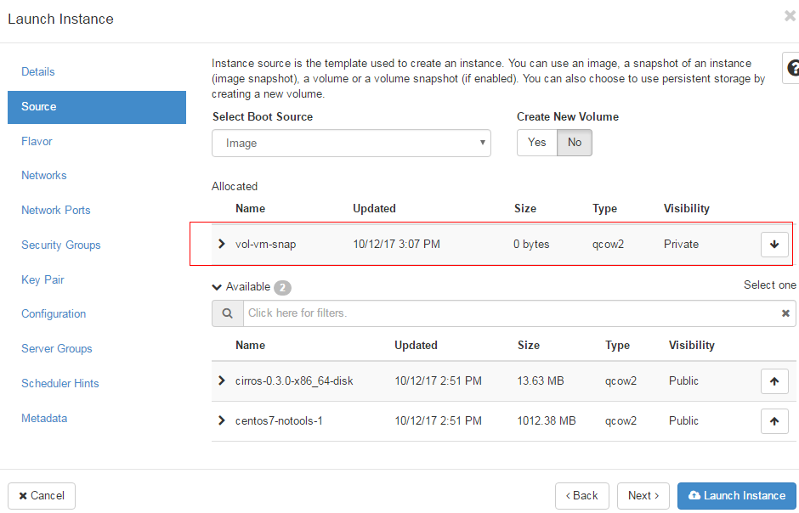
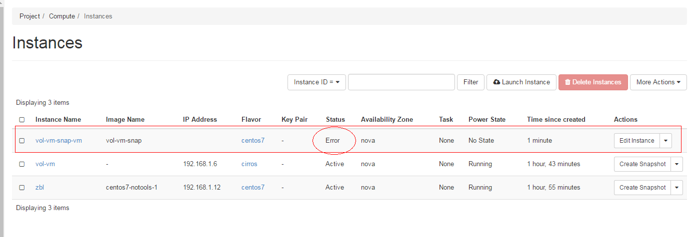
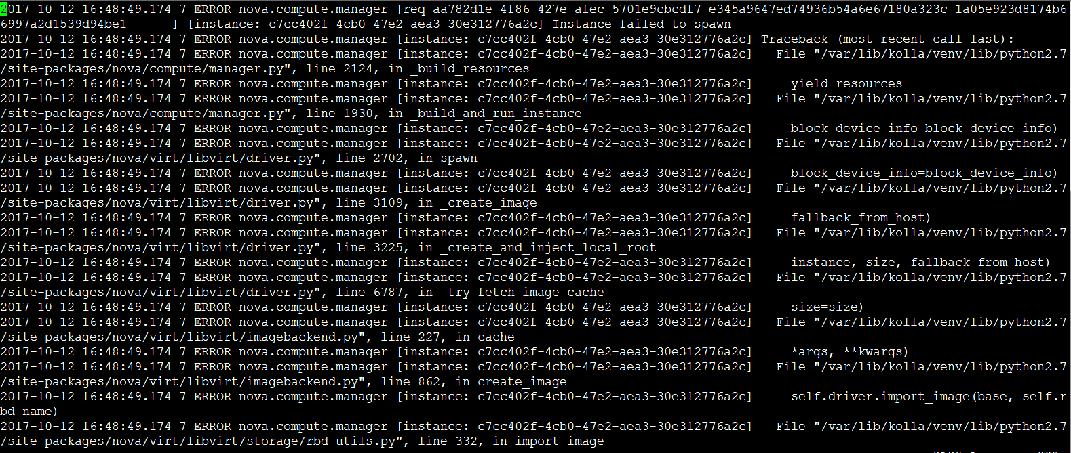
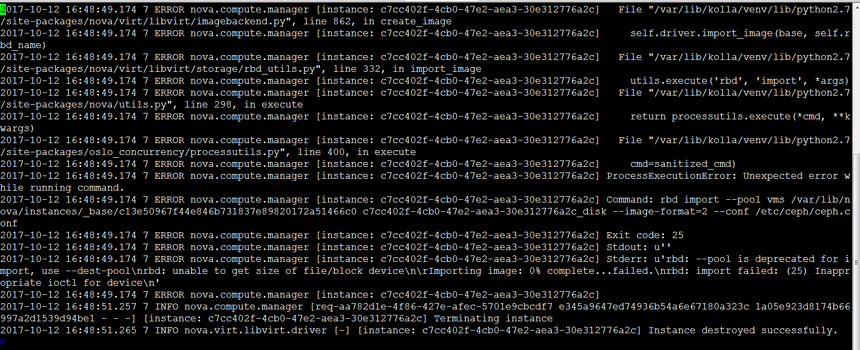
- Use this 0 bytes image(or snapshot) to create a volume failed.
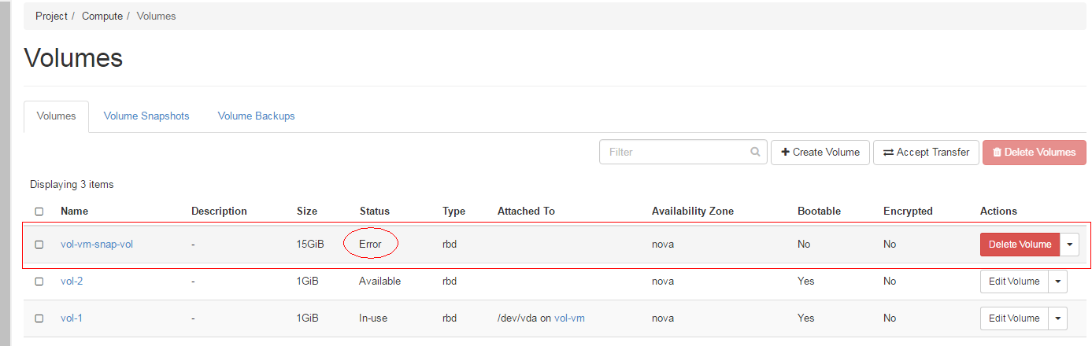
LOG:
