Prior to fix made to Create Network wizard (Original Operation)

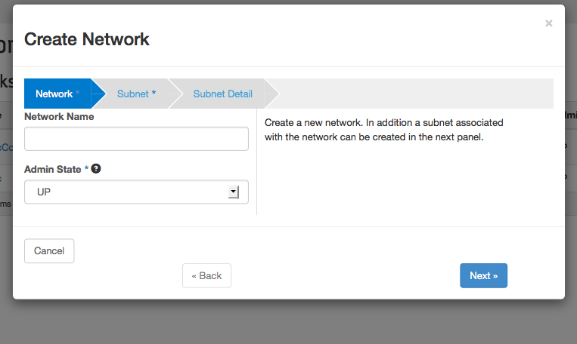

Post the fix, the new Create Network operation:

