Shelving locations in holdings editor only workstation library
3.6 shelving locations in holdings editor when multiple libraries chosen, workstation is STATELIB-L
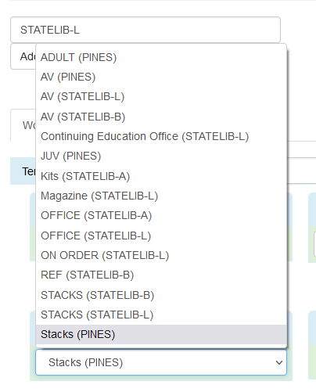

3.8 STATELIB-L workstation, multiple libraries chosen
