Holdings editor differs depending on access method

Holdings editor via Item status and item bucket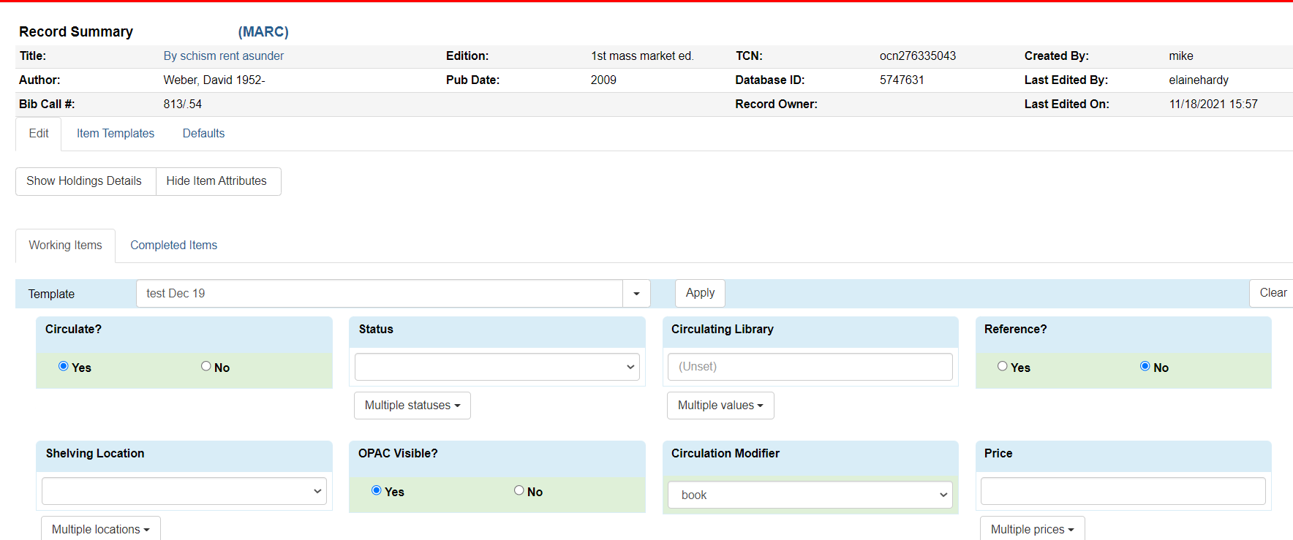

Holdings editor via holdings view in bib record
