MARC edit, traditional view, shows source
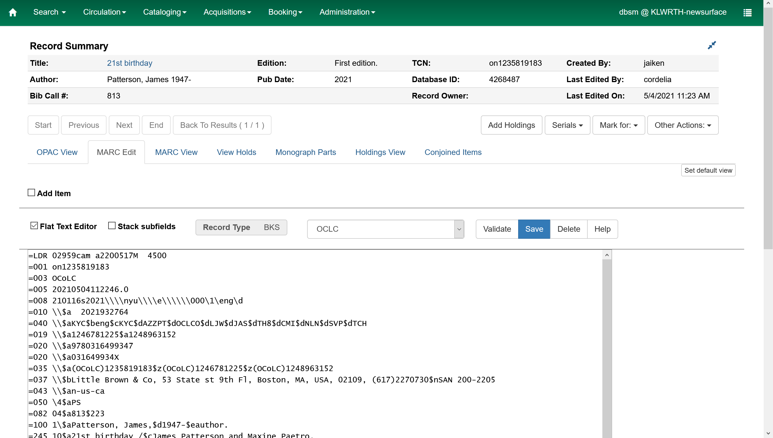
MARC edit, experimental view, not displaying source
