Search results display 3.4 with preferred library set to Three Rivers.
Searching all of PINES
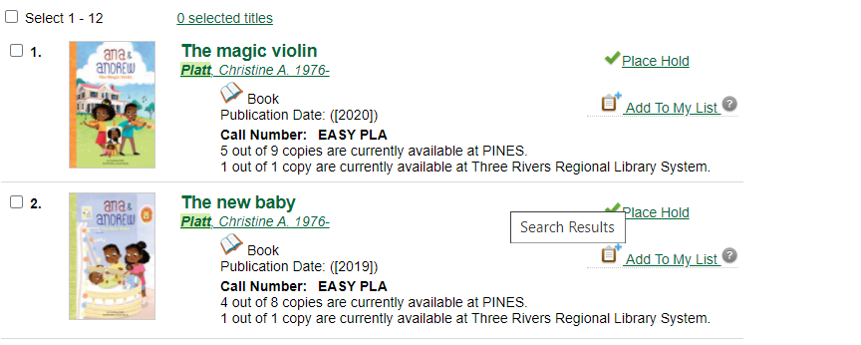

In Angular (3.6.1), preferred library Three Rivers, search library PINES. Total count of items but no preferred library count:
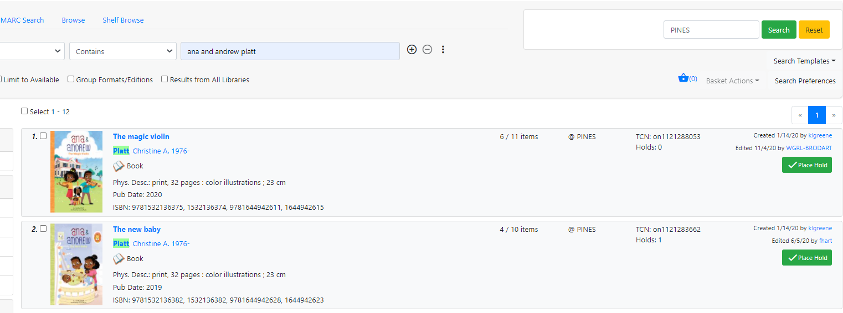

Search library TRRLS:
