Save & Exit not working in 3.5.2
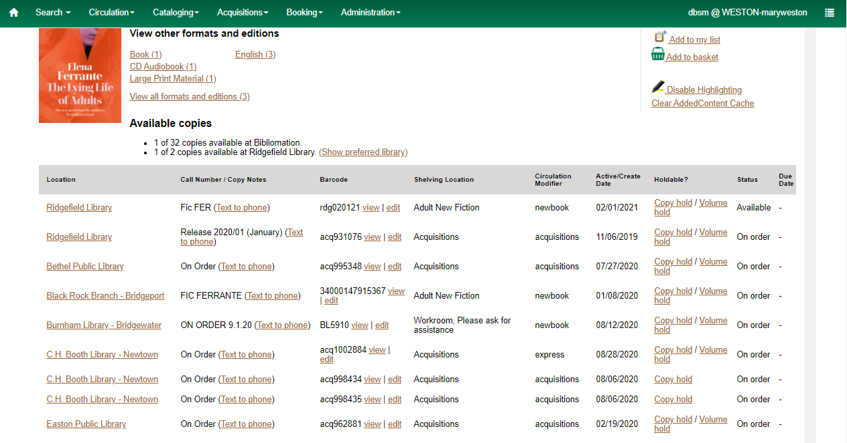

Edited item and clicked on Save & Exit. Item ended up on Completed Items instead of the Holdings Editor closing.
