https://bugs.launchpad.net/evergreen/+bug/1691269
After importing item templates from 3.0.1 XUL client, attempts to apply templates either in the Vol/copy template editor, add vols/Copies, of edit copies, the template is listed but nothing happens when applied:
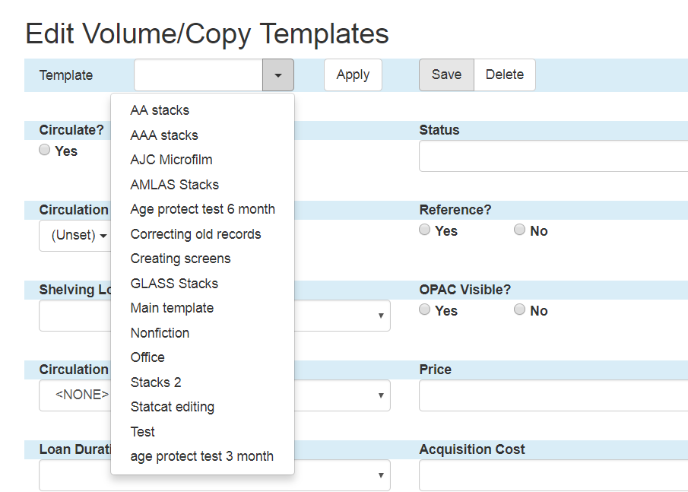

Attempt to apply a template:

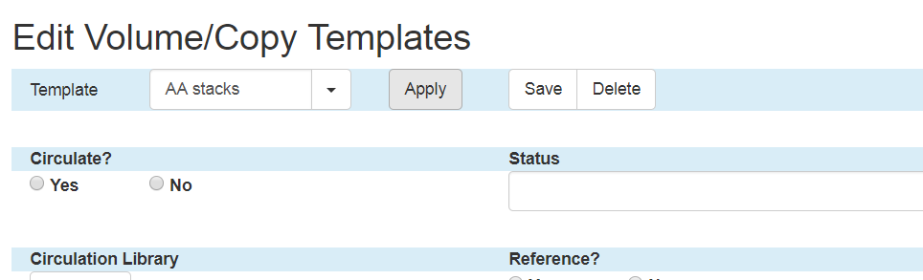

No attributes appied:

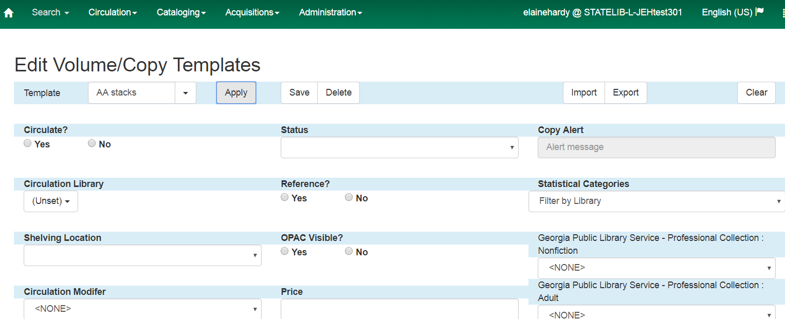

What should apply (from 3.0.1 XUL client:

