Feature Description:
Switching Scope in Catalog Searches
Dan Pearl – C/W MARS Inc. -- August 2015

References
http://masslnc.org/node/3017 - Button to Switch Catalog Scope

Summary
A common situation when performing searches is to first perform the search in a specific library, then, if insufficient results are provided, repeating the search after changing the scope of the search to the whole network.
Currently, this is accomplished by
- clicking on the drop-down for the scope of the search,
- moving the elevator to the top by a scroll-wheel action or click/drag of the elevator
- clicking on the topmost scope entry to select the entire network
- clicking on the Search button to repeat the search
The MassLNC issue also suggests that the converse action, switching to the default (single-site) scope, would be useful as well.
The objective of this enhancement is to provide shortcuts for these common workflow.

Approach #1
This approach is described in the MasLNC issue.
A clickable button is added to the search bar. If the scope drop-down value is not the whole consortium, then the control will appear as shown in this figure:
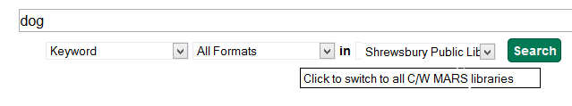
Clicking on that control will change the contents of the scope control to the whole consortium. (The text in the control is illustrative and could be derived from a configuration value if it is important to have the name of the consortium/network.)
If the scope drop-down value is the whole consortium, then the control will appear as shown in this figure:
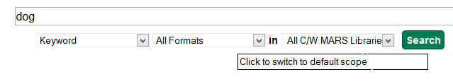
Clicking on that control will change the contents of the scope control to the “default scope”. There is no scope associated with the patron, just a home library, but this is not what is necessarily desired. If the scope is known by the subdomain of the URL, then this could be used, and the message could be customized to something like “Click to switch to Shrewsbury Public Library”.
Advantages
- It is clear what type of search is currently in effect.
Disadvantages
- Need two clicks to re-search
- Semantics of control to restrict scope not clear

Approach #2
This would create an alternate submit button to provide an instant global search.
This provides the option of searching in the selected library or in the entire network at any time.
Advantages
- The semantics and behavior of the controls are intuitive.
- Need only one click to re-search.
- Individual library to restore to is preserved and displayed at all times.
Disadvantages
- More than one Search button could be confusing.

Approach #3
This would create keep one search button, but add a selector to indicate the mode of the selection.
By default, the restricted search would be selected by the radio button. If the user wanted a global search, they would click the radio control next to “All libraries”. In both cases, the Search would need to be clicked.
The state of the radio button would be preserved (like the contents of the search box). If the user wanted to switch back to a restricted search, they would select the radio button next to the location pull-down.
Advantages
- The semantics and behavior of the controls are intuitive.
- Individual library to restore to is preserved and displayed at all times.
Disadvantages
- The radio buttons, while clear, add a bit of clutter to the display.
- Two clicks are needed to do the re-search operation.

Performance Considerations
Neither proposed implementation will slow down the search in any way perceptible by the patron.

Recommendation
Approach #2 seems a bit cleaner and clearer with respect to UI and expected behavior, so I recommend that we select this for implementation.

