Landed cost module: purchase_landed_cost
Reporting of what seems to be an error when purchase order has more than 1 line. Landed costs data are shipping are wrong and lead to a wrong Moving Average Price in product
Purchase order merged [2 products]
There is no landed costs added therefore only the line amount appears, what is correct
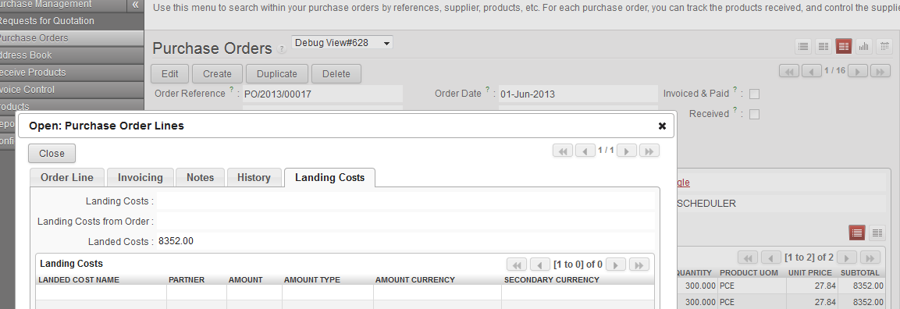
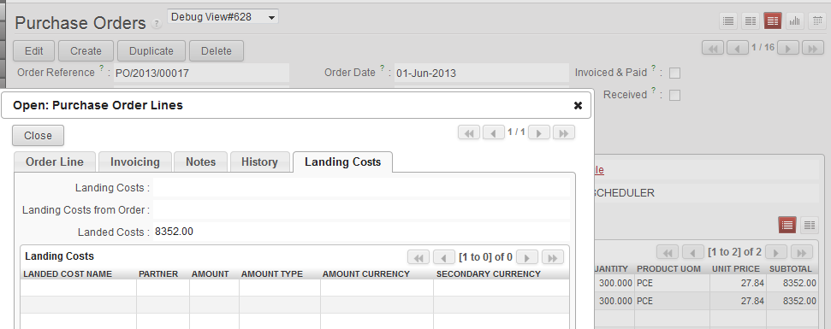
Total still correct
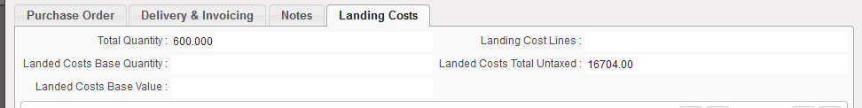

SHIPPING
Line 1 is correct: 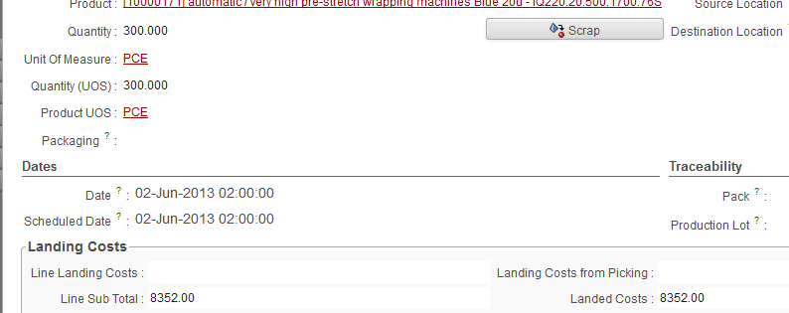
- Qty 300
- Subtotal 8352
- Landed costs (line) 8352

Line 2 is wrong:

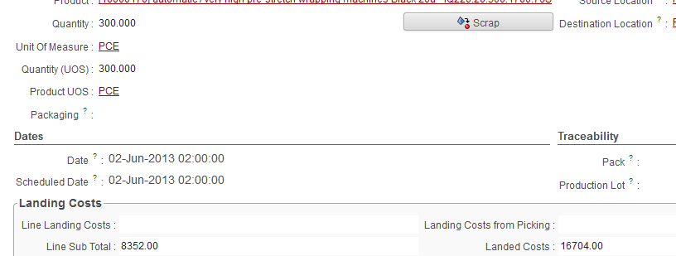
- Qty 300
- Subtotal 8352
- Landed costs (line) 16704 should be in my opinion 8352 as it referes to the line

Total shipping is wrong and calculates a wrong average price
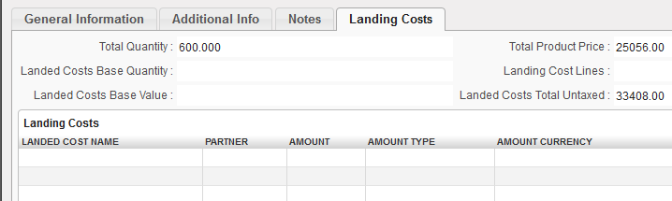
- Qty: 600 is correct
- Total product price is wrong: should be 16704
- Landed Costs Total Untaxed is wrong: should be 16704 [as for this example no additional costs were added for test purpose]

I am not (YET) a good python developer, so could you help me to correct the code?
Python stock.py
# -*- coding: utf-8 -*-
##############################################################################
#
# OpenERP, Open Source Management Solution
# Copyright (C) 2004-2010 Tiny SPRL (<http://tiny.be>).
# Copyright (C) 2010-2012 Camptocamp (<http://www.camptocamp.at>)
#
# This program is free software: you can redistribute it and/or modify
# it under the terms of the GNU Affero General Public License as
# published by the Free Software Foundation, either version 3 of the
# License, or (at your option) any later version.
#
# This program is distributed in the hope that it will be useful,
# but WITHOUT ANY WARRANTY; without even the implied warranty of
# MERCHANTABILITY or FITNESS FOR A PARTICULAR PURPOSE. See the
# GNU Affero General Public License for more details.
#
# You should have received a copy of the GNU Affero General Public License
# along with this program. If not, see <http://www.gnu.org/licenses/>.
#
##############################################################################
from osv import osv, fields
import decimal_precision as dp
import logging
#----------------------------------------------------------
# Stock Move
#----------------------------------------------------------
class stock_move(osv.osv):
_inherit = "stock.move"

def _landing_cost(self, cr, uid, ids, name, args, context):
if not ids : return {}
result = {}
landed_costs = 0.0
# landed costss for the line
for line in self.browse(cr, uid, ids):
if line.landed_cost_line_ids:
for costs in line.landed_cost_line_ids:
if costs.price_type == 'value':
landed_costs += costs.amount
else:
landed_costs += costs.amount * line.product_qty
result[line.id] = landed_costs
return result

def _landing_cost_order(self, cr, uid, ids, name, args, context):
if not ids : return {}
result = {}
landed_costs = 0.0
# landed costss for the line
for line in self.browse(cr, uid, ids):
# distrubution of landed costs of PO
if line.picking_id.landed_cost_line_ids:
if line.picking_id.total_amount and line.picking_id.total_amount > 0.0:
landed_costs += line.picking_id.landed_cost_base_value / line.picking_id.total_amount * line.price_unit * line.product_qty
if line.picking_id.quantity_total and line.picking_id.quantity_total >0.0:
landed_costs += line.picking_id.landed_cost_base_quantity / line.picking_id.quantity_total * line.product_qty
result[line.id] = landed_costs

return result

def _landed_cost(self, cr, uid, ids, name, args, context):
if not ids : return {}
result = {}
landed_costs = 0.0
# landed costss for the line
for line in self.browse(cr, uid, ids):
landed_costs += line.product_qty * line.price_unit
result[line.id] = landed_costs

return result

def _sub_total(self, cr, uid, ids, name, args, context):
if not ids : return {}
result = {}
sub_total = 0.0
for line in self.browse(cr, uid, ids):
sub_total += line.product_qty * line.price_unit_net or 0.0
result[line.id] = sub_total

return result

_columns = {
'landed_cost_line_ids': fields.one2many('landed.cost.position', 'move_line_id', 'Landed Costs Positions'),
'landing_costs' : fields.function(_landing_cost, digits_compute=dp.get_precision('Account'), string='Line Landing Costs'),
'landing_costs_picking' : fields.function(_landing_cost_order, digits_compute=dp.get_precision('Account'), string='Landing Costs from Picking'),
'landed_cost' : fields.function(_landed_cost, digits_compute=dp.get_precision('Account'), string='Landed Costs'),
'sub_total' : fields.function(_sub_total, digits_compute=dp.get_precision('Account'), string='Line Sub Total'),
'price_unit_net' : fields.float('Purchase Price', digits_compute=dp.get_precision('Account'), ),
}

stock_move()

#----------------------------------------------------------
# Stock Picking
#----------------------------------------------------------
class stock_picking(osv.osv):
_inherit = "stock.picking"

def _landed_cost_base_value(self, cr, uid, ids, name, args, context):
if not ids : return {}
result = {}
landed_costs_base_value = 0.0
for line in self.browse(cr, uid, ids):
if line.landed_cost_line_ids:
for costs in line.landed_cost_line_ids:
if costs.product_id.landed_cost_type == 'value':
landed_costs_base_value += costs.amount
result[line.id] = landed_costs_base_value
return result

def _landed_cost_base_quantity(self, cr, uid, ids, name, args, context):
if not ids : return {}
result = {}
landed_costs_base_quantity = 0.0
for line in self.browse(cr, uid, ids):
if line.landed_cost_line_ids:
for costs in line.landed_cost_line_ids:
if costs.product_id.landed_cost_type == 'quantity':
landed_costs_base_quantity += costs.amount
result[line.id] = landed_costs_base_quantity
return result

def _landed_cost(self, cr, uid, ids, name, args, context):
if not ids : return {}
result = {}
landed_costs = 0.0
# landed costss for the line
for line in self.browse(cr, uid, ids):
if line.move_lines:
for ml in line.move_lines:
landed_costs += ml.landed_cost
result[line.id] = landed_costs

return result

def _landing_cost_lines(self, cr, uid, ids, name, args, context):
if not ids : return {}
result = {}
landed_cost_lines = 0.0
for line in self.browse(cr, uid, ids):
if line.move_lines:
for ml in line.move_lines:
if ml.product_qty > 0.0:
landed_cost_lines += ml.landing_costs + ml.landing_costs_picking
result[line.id] = landed_cost_lines
return result

def _quantity_total(self, cr, uid, ids, name, args, context):
if not ids : return {}
result = {}
quantity_total = 0.0
for line in self.browse(cr, uid, ids):
if line.move_lines:
for ml in line.move_lines:
if ml.product_qty > 0.0:
quantity_total += ml.product_qty
result[line.id] = quantity_total
return result

def _amount_total(self, cr, uid, ids, name, args, context):
if not ids : return {}
result = {}
amount_total = 0.0
for line in self.browse(cr, uid, ids):
if line.move_lines:
for ml in line.move_lines:
if ml.product_qty > 0.0 and ml.price_unit:
amount_total += ml.sub_total
result[line.id] = amount_total
return result

_columns = {
'landed_cost_line_ids': fields.one2many('landed.cost.position', 'picking_id', 'Landed Costs Positions'),
'landed_cost_base_value' : fields.function(_landed_cost_base_value, digits_compute=dp.get_precision('Account'), string='Landed Costs Base Value'),
'landed_cost_base_quantity' : fields.function(_landed_cost_base_quantity, digits_compute=dp.get_precision('Account'), string='Landed Costs Base Quantity'),
'landing_cost_lines' : fields.function(_landing_cost_lines, digits_compute=dp.get_precision('Account'), string='Landing Cost Lines'),
'landed_cost' : fields.function(_landed_cost, digits_compute=dp.get_precision('Account'), string='Landed Costs Total Untaxed'),
'total_amount' : fields.function(_amount_total, digits_compute=dp.get_precision('Account'), string='Total Product Price'),
'quantity_total' : fields.function(_quantity_total, digits_compute=dp.get_precision('Product UoM'), string='Total Quantity'),
}

stock_picking()

class stock_partial_picking(osv.osv_memory):
_inherit = "stock.partial.picking"
_logger = logging.getLogger(__name__)

def _product_cost_for_average_update(self, cr, uid, move):
res = super(stock_partial_picking, self)._product_cost_for_average_update(cr, uid, move)
self._logger.debug('res stock_partial_picking `%s`', res)
res['cost'] = move.landed_cost / move.product_qty
self._logger.debug('res stock_partial_picking `%s`', res)
return res

stock_partial_picking()

